Setting a New Endoscopic Retrograde Cholangiopancreatography Team: A Challenge in Establishing a Competent Team and Early Outcomes of ERCP in Sakon Nakhon Hospital

Nisit Tongsiri¹, MD , Witchuda Kittiwararit², M.N.S

¹Department of Surgery and ²Department of Nursing, Sakon Nakhon Hospital, Sakon Nakhon, Thailand.
Abstract

Objectives: The objective of this study is to analyze a team’s learning curve for ERCP in a novice team, and to gather information regarding successful cannulation rate and procedural- related complications for ERCP in Sakon Nakhon Hospital.
Materials and Methods: A retrospective study with data collection from elective ERCPs performed by a single experienced operator with a novice ERCP team in Sakon Nakhon Hospital from August 2015 to July 2017. The team's learning curve was analyzed by plotting average cannulation time (ACT) and average total operating time (ATOT) of a block of ten ERCPs in native papilla against the operation sequence. Data regarding successful cannulation rate in natural papilla and procedural related complications were gathered to evaluate team competency in ERCP.

Results: There were 222 elective ERCPs in the studied period; 175 ERCPs of these ERCPs were native papilla. Total successful cannulation rate in native papilla was 83.4%. ACT and ATOT became steadier after 70th ERCPs which was set as point of reaching learning curve plateau (LCP). ACT and ATOT significantly decreased after reaching LCP (29.2 min vs 18.3 min, p<0.01, 95%CI 3.4-18.5 and 66.8 min vs 49.7 min, p<0.01, 95%CI 8.3-25.9, respectively). Successful cannulation rate in the last 15 ERCPs in the study was 93.3%. Cholangitis and pancreatitis cases before and after reaching LCP were not significantly different during the studied period (3 vs 15, p=0.074 and 10 vs 17, p=0.91, respectively).

Conclusions: It needed approximately 70 ERCPs to be performed by novice ERCP team to ensure effective teamwork.

Keywords: ERCP, learning curve, ERCP team
การสร้างทีมส่องกล้องตรวจท่อน้ำดีและตับอ่อน: ความท้าทายในการสร้างทีมส่องกล้องตรวจท่อน้ำดีและตับอ่อนในโรงพยาบาลสกลนครและผลการดำเนินงานเบื้องต้น
นิสิต ตงศิริ, พ.บ. และ วิชชุดา กิตติวราฤทธิ์, พย.บ.
กลุ่มงานศัลยกรรม และกลุ่มงานพยาบาล โรงพยาบาลสกลนคร
บทคัดย่อ
วัตถุประสงค์
การศึกษานี้ทำขึ้นเพื่อศึกษาเส้นโค้งในการเรียนรู้ของทีมในการทำหัตถการ ERCP และความสำเร็จในการใส่สายเข้าในท่อน้ำดี รวมถึงผลแทรกซ้อนที่เกิดขึ้นจากการทำหัตถการนี้ ในโรงพยาบาลสกลนคร
วิธีการ
การศึกษานี้เป็นการศึกษาแบบย้อนหลัง โดยเก็บข้อมูลจากคนไข้ที่ทำ ERCP ในโรงพยาบาลสกลนครตั้งแต่เดือนสิงหาคม พ.ศ. 2558 ถึง เดือนกรกฎาคม พ.ศ. 2560 โดยหัตถการที่ทำจะทำโดยผู้ทำหัตถการคนเดียว ร่วมกับทีมส่องกล้องที่ไม่เคยทำงานร่วมกันมาก่อน ผู้ป่วยที่ต้องทำหัตถการเนื่องจากภาวะฉุกเฉินเร่งด่วน ผู้ป่วยที่มีการอุดตันของทางออกของกระเพาะอาหาร และผู้ป่วยที่เคยผ่าตัดทำทางต่อระหว่างลำไส้เล็กและกระเพาะอาหารจะไม่อยู่ในขอบเขตของการศึกษานี้
การประเมินเส้นโค้งการเรียนรู้จะทำโดยใช้ค่าเฉลี่ยของระยะเวลาการสอดสายนำ (Guide wire )เข้าในท่อน้ำดี กับค่าเฉลี่ยของระยะเวลาทั้งหมดในการทำหัตถการในผู้ป่วย 10 คน ทำเป็นจุดประตามจำนวนหัตถการ ERCP ทั้งหมด และใช้ผลแทรกซ้อนหลักที่เกิดจากการทำหัตถการคือการเกิดตับอ่อนอักเสบและท่อน้ำดีอักเสบในการทำการส่องกล้องตรวจท่อน้ำดีและตับอ่อนประเป็นจุดในช่วงการทำหัตถการ 10 ครั้ง ไปจนครบการทำหัตถการทั้งหมด 222 ครั้ง อัตราการสอดสายนำเข้าท่อน้ำดีสำเร็จและผลแทรกซ้อนต่างๆจะถูกเก็บเพื่อใช้ประเมินความสามารถของทีมงานในการทำ ERCP
ผลการรักษา
มีการทำ ERCP แบบไม่ฉุกเฉินในระหว่างระยะเวลาทำการศึกษาทั้งสิ้น 222 ครั้ง ในจำนวนนี้ จะเป็นการทำหัตถการในผู้ป่วยที่ยังไม่เคยทำหัตถการนี้มาก่อน 175 ราย การใส่สายนำเข้าท่อน้ำดีทำได้สำเร็จ 83.4% ภายหลังจากการทำหัตถการไปได้ 70 ครั้งพบว่าระยะเวลาทั้งหมดที่ใช้ทำหัตถการเริ่มคงที่ โดยถือว่าการทำหัตถการถึง 70 ครั้งเป็นจุดคงที่ของเส้นโค้งการเรียนรู้ และเมื่อเปรียบเทียบค่าเฉลี่ยของเวลาการใส่สายนำเข้าท่อน้ำดีก่อนและหลังการเข้าสู่จุดคงที่ของเส้นโค้งการเรียนรู้ซึ่งเป็น 29.2 นาที กับ 18.3 นาทีพบว่ามีความแตกต่างกันอย่างมีนัยสำคัญทางสถิติ ( p<0.01, 95%CI 3.4-18.5) เช่นเดียวกับค่าเฉลี่ยของระยะเวลาการทำหัตถการก่อนและหลังการเข้าสู่จุดคงที่ของเส้นโค้งการเรียนซึ่งเป็นเวลา 66.8 นาทีกับ 49.7 นาที ซึ่งพบว่ามีความแตกต่างกันอย่างมีนัยสำคัญทางสถิติ ( p<0.01, 95%CI 8.3-25.9) เช่นกัน
นอกจากนั้นอัตราการใส่สายนำเข้าท่อน้ำดีได้สำเร็จยังเพิ่มขึ้นเป็น 93.6 เปอร์เซ็นต์ในการทำหัตถการ 15 ครั้งสุดท้าย
อัตราการเกิดผลแทรกซ้อนหลักคือท่อน้ำดีอักเสบและตับอ่อนอักเสบจะคงที่ตลอดการศึกษาไม่มีความแตกต่างกันอย่างมีนัยสำคัญทางสถิติระหว่างการเกิดท่อน้ำดีอักเสบก่อนและหลังการเข้าสู่จุดคงที่ของเส้นโค้งการเรียนรู้ (3 ราย กับ 15 ราย, p=0.074) และการเกิดตับอ่อนอักเสบก่อนและหลังการเข้าสู่จุดคงที่ของเส้นโค้งการเรียนรู้ (10 ราย กับ 17 ราย, p=0.91).
ผลแทรกซ้อนที่สำคัญคือการเกิดตับอ่อนอักเสบหลังการทำหัตถการ เกิดขึ้นในการทำหัตถการ 27 ครั้ง ท่อน้ำดีอักเสบเกิดขึ้น 18 ครั้ง ท่อระบายน้ำดีเลื่อน เกิด 3 ครั้ง เลือดออกภายหลังการทำหัตถการเกิดขึ้น 2 ครั้ง หัวใจวายเกิดขึ้น 1 ครั้ง หัวใจห้องบนสั่นพลิ้วเกิดขึ้น 1 ครั้ง โรคหลอดเลือดหัวใจเกิด 1 ครั้ง และเกิดการทะลุของลำไส้จากการทำหัตถการ 1 ครั้ง การเสียชีวิตอันเกี่ยวเนื่องจาการทำหัตถการ ERCP เกิดในผู้ป่วย 8 รายโดย 7 ใน 8 รายผู้ป่วยเป็นมะเร็งท่อน้ำดี (เป็นมะเร็งท่อน้ำดีที่ขั้วตับ 4 ราย และเป็นมะเร็งท่อน้ำดีรวมส่วนปลาย 3 ราย) ผู้ป่วยที่เสียชีวิตเป็นผู้ป่วยนิ่วในท่อน้ำดี 1 ราย สาเหตุการเสียชีวิตเป็นจากการติดเชื้อในท่อน้ำดี 5 ราย ตับอ่อนอักเสบ 1 ราย ลำไส้เล็กทะลุร่วมกับตับอ่อนอักเสบในผู้ป่วย 1 ราย และเสียชีวิตจากภาวะหัวใจวาย 1 ราย
สรุป
การทำหัตถการส่องกล้องตรวจระบบท่อน้ำดีและตับอ่อนเป็นหัตถการที่ยาก และมีผลแทรกซ้อนรุนแรงที่อาจทำให้เกิดการเสียชีวิตได้สูง โดยเฉพาะการทำหัตถการนี้ในผู้ป่วยมะเร็งท่อน้ำดีมีโอกาสเกิดท่อน้ำดีอักเสบหลังการทำหัตถการได้ การทำหัตถการนี้นอกจากต้องอาศัยความสามารถของผู้ทำหัตถการแล้ว ทีมงานที่ทำหัตถการก็มีความสำคัญ และใช้จำนวนการทำหัตถการ ERCP ในการเรียนรู้การทำงานร่วมกันทำให้เกิดการทำหัตถการได้อย่างมีประสิทธิภาพมากถึง 70 ครั้ง จึงจะผ่านจุดคงที่ของเส้นโค้งการเรียนรู้

Introduction
Endoscopic retrograde cholangiopancreatography (ERCP) is a complex endoscopic procedure which requires a long learning curve for ERCP operators to reach acceptable and successful cannulation. According to previous studies, to reach a 80-90% success rate of cannulation in ERCP, the operator had to perform 79-400 ERCPs under supervision¹. Moreover, ERCP has potential serious complications, such as post-ERCP pancreatitis, bleeding, perforation, and cholangitis² which may lead to death of the patients. Therefore, competent operators and a well-set-up team of endoscopic nurses, nurse assistants, and proper ERCP instruments are required for ERCP².
In northeastern Thailand, ERCP is more generalized, as the distribution and access of healthcare to patients is better than in the past. Therefore, this procedure is not limited to teaching university hospitals; nowadays, it is distributed to many provincial hospitals and some district hospitals as well. Since ERCP cannot be completed by just a competent operator, an ERCP team is also important; however, there is no set number of ERCPs to create a competent ERCP team from a novice ERCP team.
Distribution of ERCP to provincial and district hospitals can generate a lower volume of ERCP in each respective center. It is believed that high ERCP volume is associated with lower procedural related complications^{3,4}. However, there are studies from low-volume centers which performed less than 200 ERCPs per year that had comparable complication rates with high volume centers which performed more than 1000 ERCPs per year⁵⁻⁷. As studies about the relationship between the central volume of ERCP and procedural related complications have not been consistent, procedural-related complications should be monitored as an audit for potential improvement of the ERCP team, especially in a novice or low-volume ERCP center.
There are high incidences of cholangiocarcinoma in northeastern Thailand. The incidence of cholangiocarcinoma in the Khon Kaen province in northeastern Thailand was 135.4 per 100,000 among males, and 43 among females⁸ . Sakon Nakhon is also a province in northeastern Thailand, and the incidence of cholangiocarcinoma in Sakon Nakhon may be as the same as in the Khon Kaen province. According to the previous studies, ERCP in inoperable hilar cholangiocarcinoma is associated with high incidence of cholangitis⁹⁻¹¹. Therefore, ERCP related complications in centers that have high proportions of cholangiocarcinoma patients may be higher than complication rates reported from studies which had lower proportions of cholangiocarcinoma cases.
This study aims to analyze learning curves for the ERCP procedure, and to gather information regarding successful cannulation rate and procedural related complications for ERCP in Sakon Nakhon Hospital. Successful cannulation rates and complication rates of ERCP are used as an audit for improvement of safety and efficacy in ERCP procedures in Sakon Nakhon Hospital.

Materials and Methods
This study was performed in a novice tertiary care hospital that is responsible for a health area of approximately 1,140,000 inhabitants in Sakon Nakhon Province¹². ERCP was first done by Sakon Nakhon Hospital’s own staff in August 2015. The operator had performed more than 120 ERCPs as an independent operator at Khon Kaen Hospital, which had more than 300 ERCP cases per year¹³ before he moved to Sakon Nakhon Hospital. The ERCP team in Sakon Nakhon Hospital, which included endoscopic nurses and nurse assistants, were trained by the author, Tongsiri N, and coauthor, Kittiwararit W. The coauthor is a certified operating room nurse, who was trained at Rajavithi Hospital, one of the leading endoscopic centers in Thailand. The members of this novice ERCP team had never worked together before. Although the author and coauthor have some experience in ERCP, other team members had no experience in ERCP; therefore, the number of ERCPs needed for the team to reach the point that all members in this team could work together effectively was a point of investigation in this study.
ERCP in Sakon Nakhon Hospital was performed with Olympus TJF-150 Video Duodenoscope, triple lumen sphincterotome (KD-V14M-075), and 0.025-inch guide wire was used for cannulation of ampulla of Vater. Patients had been informed about the details of the ERCP procedure and possible complications. The alternative methods of treatments and investigations had been discussed with the patients, then permission for ERCP from the patients was obtained. Before ERCPs were performed, the prophylaxis antibiotic, mostly intravenous Ceftriaxone 2 gm, was given to the patients. In Sakon Nakhon Hospital, the majority of the patients received ERCP under monitored anesthesia care (MAC). They also received two percent lidocaine spray as a local anesthetic agent, and they were monitored for blood pressure, heart rate, and oxygen saturation during the procedure by nurse anesthetists. After ERCPs, the patients were observed for possible complications for at least 24 hours after operation.
Successful cannulation was defined as deep cannulation and adequate visualization of duct of interest⁷. Successful intervention in common bile duct (CBD) stone cases was defined as complete clearance of CBD stones, or drainage of CBD with stent in large CBD stone cases. In malignancy, benign biliary stricture, and bile leakage, successful intervention was defined as successful placement of stent in the selected bile duct. Cannulation time was defined as period of time in minutes, starting from oral intubation of duodenoscope to successful cannulation. Total operative time was the period of time in minutes, starting from oral intubation of duodenoscope to removal of duodenoscope from the patients.
Post-ERCP pancreatitis (PEP) was defined as abdominal pain after ERCP, with increased amylase level at least three-times of normal upper limit more than 24 hours after procedure. Post-ERCP cholangitis was defined as abdominal pain with obstructive jaundice, and fever of more than 38 degrees Celsius that persisted for more than 24 hours. Post-ERCP hemorrhage was diagnosed when there was evidence of bleeding during the procedure and drop of hemoglobin more than 2 g/dL from baseline hemoglobin. ERCP related perforation was evidenced by contrast leakage in abdominal cavity or retroperitoneal cavity during ERCP, or evidence of free air in abdominal cavity or air in retroperitoneal cavity from imaging study¹⁵.
Data collection from patients who underwent elective ERCP at Sakon Nakhon Hospital from August 2015 to July 2017 by the author, regarding patient demographics, indications for ERCPs, cannulation time, total operation time, successful cannulation, successful intervention, and procedural-related complications were collected. Types of hilar cholangiocarcinoma were staged from pre-ERCP imaging, according to Bismuth classification¹⁶. Emergency ERCPs, ERCPs in gastric outlet obstruction, and ERCPs in gastrojejunostomy patients were excluded from the study. The team's learning curve was analyzed by a plot of average cannulation time (ACT) from a block of ten ERCPs against operation sequence in 175 native papilla cases, as well as the average total operating time (ATOT) of block of ten ERCPs against operation sequence in 175 native papilla cases¹⁴, and a plot of procedural-related complications which included pancreatitis and cholangitis from 222 ERCPs. Data regarding successful cannulation rate in natural papilla and procedural related complications from all of elective 222 ERCPs were gathered to evaluate team competency in the ERCP.

Results
From August 2015 to July 2017, there were 222 elective ERCPs in the studied period; 175 ERCPs of these were native papilla. The median age of patients was 66 years old, from a total sample of 20-93 years old, with 60% male and 40% female. The indications for ERCPs were common bile duct stone in 92 ERCPs, malignancy in 68 ERCPs, benign biliary stricture in 23 ERCPs, gallstone pancreatitis in six ERCPs, and bile leakage in three ERCPs. Characteristics and indications for ERCPs is shown in table 1, and classification of malignancy cases according to tumor site is shown in table 2.
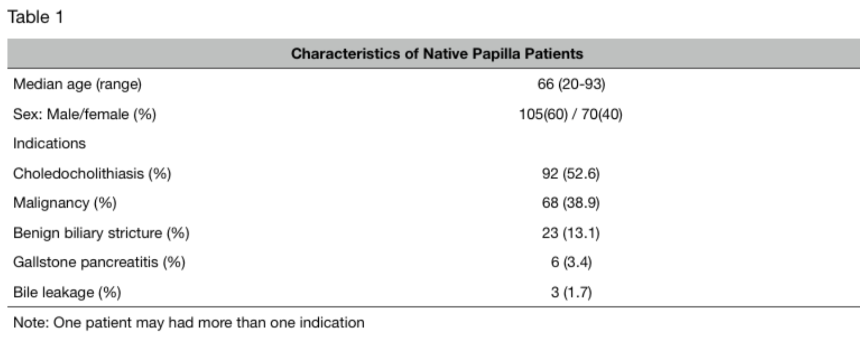

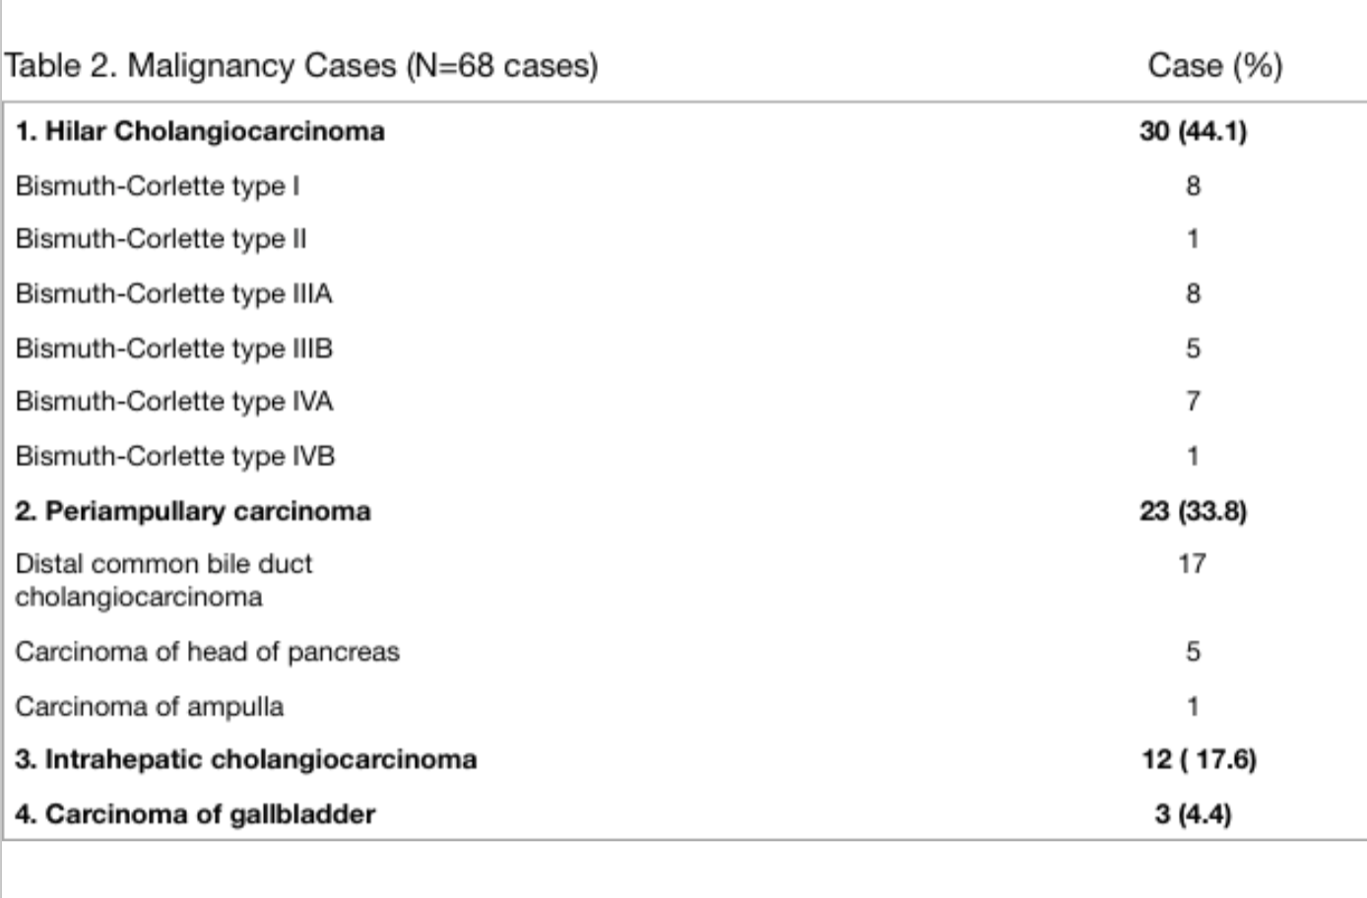
Total successful cannulation rate in native papilla was 83.4% at the first attempt. Cannulation time and total operative time became steadier after the 70th ERCP. The average cannulation time decreased from 39.2 minutes in the first ten ERCPs to 11.7 minutes in the 71st to 80th ERCPs. ATOT decreased from 93.6 minutes in first ten ERCPs to 39 minutes in 71st to 80th ERCPs; therefore, the learning curve plateau (LCP) started after 70th ERCP. The successful cannulation rate in the last 15 ERCPs in natural papilla (161st - 175th ERCP) was 93.3%. Plot of ACT and ATOT of block of ten ERCPs against operation sequence was demonstrated in picture 1.

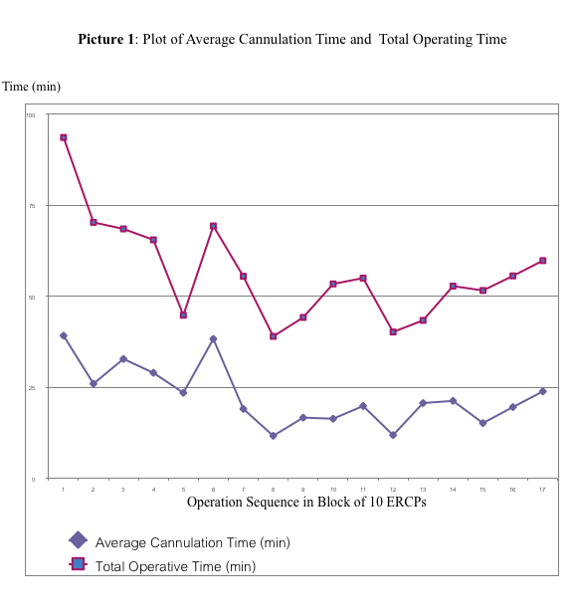
The ACT and ATOT after reaching LCP significantly decreased from ACT and ATOT before reaching LCP as describe in table 3.
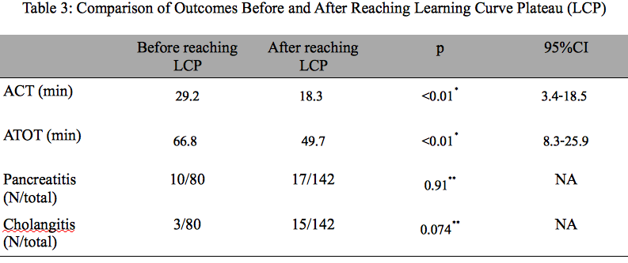

* = Comparison of two means by student's t-test
** = Analysis of categorical data with Fisher's exact test
ACT = average cannulation time, ATOT = average total operating time, NA = Not assessed
95%CI = 95% confidence interval, N/total = number of cases with complication/ total ERCP cases
There were eight cases which had incomplete data collection of cannulation time: four cases in block of 1st-10th ERCP, one case in block of 11th - 20th ERCP, one case in block of 31st - 40th ERCP, one case in block of 51st - 60th ERCP, and one case in block of 61st - 70th ERCP. For total operating time, the data collection was complete in every block. A plot of number of main complications (post-ERCP pancreatitis and post-ERCP cholangitis) against total 222 ERCPs in block of ten ERCPs was shown in picture 2 and the rate of main complications were stable during all of the studied period, there was no significant different between post-ERCP pancreatitis and post-ERCP cholangitis before and after reaching LCP as demonstrated in table 3.
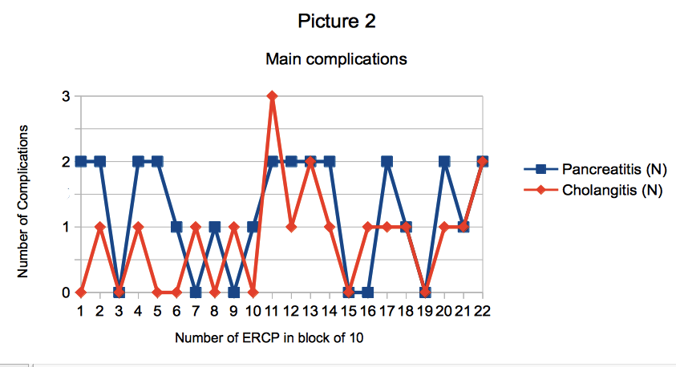

The complications from 222 ERCPs were pancreatitis in 27 ERCPs (12.1%), cholangitis in 18 ERCPs (8.1%), stent migration in three ERCPs (1.4%), bleeding in two ERCPs (0.9%), congestive heart failure in one ERCP (0.5%),atrial fibrillation in one ERCP (0.5%), acute coronary syndrome in one ERCP (0.5%), and perforation in one ERCP (0.5%). There were eight procedural related mortality cases; seven of eight deaths were cholangiocarcinoma cases (four hilar cholangiocarcinoma cases and three distal common bile duct cholangiocarcinoma cases), one of eight procedural related deaths was a common bile duct stone case; the causes of death were: cholangitis in five cases, pancreatitis in one case, perforation with pancreatitis in one case, and congestive heart failure in one case. Causes of death and indications for ERCPs were demonstrated in table 4.
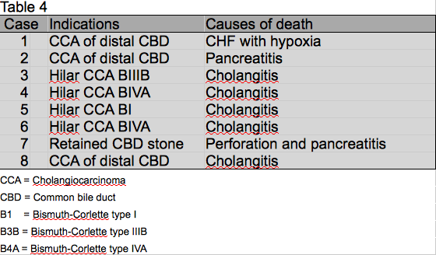

Discussion
Although the author and coauthor had experience in ERCP before establishing the ERCP team in Sakon Nakhon Hospital, there were significant amount of ERCP to be performed by the novice team to reach the team's learning curve. From this study, the team needed at least 70 ERCPs to have steady cannulation time and total operating time. The result from this study had a longer learning curve in comparison to a previous study from the author, which was presented at the International Digestive Disease Forum 2016 at Hong Kong, and the abstract was published in Clinical Gastroenterology and Hepatology in 2017.From the previous study, the learning curve for the team was only 40 ERCPs¹⁷, and this might be explained by smaller population of ERCP cases in the previous study, which had 93 ERCPs in 79 patients, and according to a plot of average total operating time of block of ten ERCPs against operation sequence (picture 1), there was a sharp drop in total operative time after 40th ERCP. However, the total operating time increased again after the 50thERCP, then total operating time dropped again after 70th ERCP and became steady. Therefore, the first drop in total operating time after the 40th ERCP could be easily misinterpreted as the point that the team passed the learning curve if there was too small of an amount of ERCPs to be followed after the 40thERCP. As there were significant amounts of ERCP to be performed to reach the team learning curve, it is suggested that ERCP should be performed in newly established centers with close monitor and support from specialized endoscopic centers at least in their first 70 ERCP.
Successful cannulation is very important for ERCP. The successful cannulation rate of more than 80% is recommended by the American Society for Gastrointestinal Endoscopy (ASGE) as a competency marker¹⁸. Total successful cannulation rate in this study was acceptable, as total successful cannulation rate was 83.4%; furthermore, in the last 15 ERCP from the study, successful cannulation rate became 93.3%. The successful cannulation rate that reached over 80% might confirm that the operator in this study was at least a competent ERCP operator during the studied period. The improvement of cannulation time and total operating time might reflect both improvement of the operator’s skills and better coordination between healthcare professions in the ERCP team.
The major procedural-related complications of ERCP are: post-ERCP pancreatitis (PEP), post-ERCP cholangitis, and post-sphincterotomy bleeding and perforation. In this study, PEP was 12.1%, higher than previous studies from centers which had similar ERCP-volume per year to Sakon Nakhon Hospital (A low-volume ERCP unit which had less than 200 ERCPs per year). Garcia-Cano Lizcano reported 5.5% of PEP from a center which performed 84 ERCPs per year in Spain⁶, and Riesco-Lopez reported a PEP rate of 11% in the first 100 ERCPs, and 4% in following 100 ERCPs, in a low-volume center in Spain⁷. Generally, PEP should be less than 7%, according to accepted benchmarks¹⁹; however, this study had higher rates of PEP than the accepted benchmark. The higher rate of PEP might be due to the definition of PEP, which, according to Cotton, was abdominal pain with rising in serum amylase at least three times normal at more than 24 hours after ERCP and requiring admission or prolongation of planned admission to 2-3 days¹⁵. In this study, all of the ERCP patients were admitted in the hospital, and it was easier to detect abdominal pain in admitted patients than in outpatients, as the ERCP patients who underwent ERCP on outpatient regime with mild abdominal pain might not complain about their abdominal pain during a follow-up. Therefore, the rate of PEP from the retrospective series which performed ERCP on outpatient regime might be lower than it should be. In this study, PEP was responsible for a 0.9% mortality rate from 222 ERCP patients . In a systematic review which included 13,296 ERCP patients, PEP incidence was 9.7%, and mortality rate of PEP was 0.7% ²⁰. Therefore, the mortality rate from PEP in this study was slightly higher than previous studies.
In this study, the rate of cholangitis was 8.1%, it was high in comparison with studies from Garcia-Cano Lizcano and Riesco-Lopez,which reported cholangitis rates of 1.3% and 2.5%, respectively^{6,7}. The high rate of cholangitis in this study might due to the high proportion of palliative endoscopic biliary drainage for hilar cholangiocarcinoma in this study, as there is high incidence of cholangiocarcinoma in northeastern Thailand⁸. According to previous studies, palliative endoscopic biliary drainage for hilar cholangiocarcinoma was responsible for a high rate of cholangitis, ranging from 8.8-40.7% ^{7, 21- 23}. The rate of post-ERCP cholangitis was especially high in hilar cholangiocarcinoma Bismuth-Corlette type III and IV, as Rerknimitr reported post-ERCP cholangitis 57.7% in Bismuth-Corlette type III and IV hilar cholangiocarcinoma¹⁰.
The rate of post-sphincterotomy bleeding and perforation was comparable with previous studies, which reported bleeding complications of 1.2%- 8% and perforation 0.4-4.6%^{6,7,15}, These complications were within the accepted benchmarks of quality indicators for ERCP, which accepted bleeding complication less than 2% and less than 2% perforation ².
In this study, there were eight deaths (3.6% mortality rate) from 222 elective ERCPs. Seven of eight deaths were malignancy cases, which included four hilar cholangiocarcinoma cases and three distal common bile duct cholangiocarcinoma cases. Post-ERCP cholangitis was responsible for all of four deaths in hilar cholangiocarcinoma, and it was responsible for one in three deaths from distal common bile duct cholangiocarcinoma cases. The other two deaths in the distal common bile duct cholangiocarcinoma were from pancreatitis and congestive heart failure with hypoxia. Therefore, as there were 30 cases of hilar cholangiocarcinoma and 17 distal common bile duct cholangiocarcinoma cases in this study, the mortality rate in hilar cholangiocarcinoma and distal common bile duct cholangiocarcinoma from ERCP-related complications was 13.3% and 11.8%, respectively. From previous studies, ERCP-related mortality was 2.5-15% for ERCPs in hilar cholangiocarcinoma patients ^{11,21,22, 24,25}, and 2.2-9% for ERCP in distal common bile duct malignancy patients ²⁶⁻²⁸.
The ERCP-related mortality in hilar cholangiocarcinoma and distal common bile duct cholangiocarcinoma patients in this study was comparable with aforementioned studies. The endoscopic biliary drainage has been recognized as the preferred treatment for palliative treatment of hilar cholangiocarcinoma^{25,29} ;however, there are some studies stating that the procedural-related mortality rate of palliative endoscopic biliary drainage procedure for hilar cholangiocarcinoma was high as mentioned above, and there were retrospective studies^{30,31} demonstrating better efficacy and fewer complications of percutaneous biliary drainage for palliation of malignant hilar obstruction. Therefore, the most appropriate palliative treatment for inoperable hilar cholangiocarcinoma is still debated.

Conclusions
There were approximately 70 ERCPs performed by the ERCP team, ensuring effective teamwork. The PEP complication in this study was higher than previous studies due to inpatient regime of ERCP. The post-ERCP cholangitis was very high in comparison with previous studies from non-endemic area of cholangiocarcinoma. However, post-ERCP cholangitis and mortality rates from ERCP-related complications in hilarcholangiocarcinoma was comparable with previous studies that performed ERCP for palliative biliary drainage in hilar cholangiocarcinoma. Post-sphincterotomy bleeding and peroration in this study were in acceptable rates, according to accepted benchmarks of quality for ERCP.

References
1.Shahidi N, Ou G, Telford J, Enns R. When trainees reach competency in performing ERCP: a systematic review. Gastrointestinal Endoscopy 2015; 81(6): 1337-1342.
2.Kachaamy TA, Faigel D. Improving ERCP quality and decreasing risk to patients and providers. Expert Rev. Gastroenterol. Hepatol 2013; 7(6): 531-540.
3.Kapral C, Duller C, Wewalka F, et al. Case volume and outcome of endoscopic retrograde cholangiopancreatography: result of a nationalwide Austrian benchmarking project. Gastrointestinal Endoscopy 2008; 40(8), 625-630.
4. Freeman ML, Nelson DB, Sherman S, et al. Complications of endoscopic biliary sphincterotomy. N. Engl. J. Med 1996; 355(13), 909-918.
5.Enochsson I, Swahn F, Arnelo U, et al. Nationalwide, population-based data from 11,074 ERCP procedures from the Swedish Registry for Gallstone Surgery and ERCP. Gastrointestinal Endoscopy 2010; 72(6), 1175-1184.
6.Garcia-Cano Lizcano J, Gonzalez Martin JA, Morillas Arino J, et al. Complications of endoscopic retrograde cholangiopancreatography. Rev Esp Enfrem Dig. 2004; 96 (3): 163-173.
7.Riesco-Lopez JM, Vazquez-Romero M, Rizo-Pascual JM, Rivero-Fernandez M, et al. Efficacy and safety of ERCP in a low-volume hospital. Rev Esp Enferm Dig(Madrid) 2013; 105(2): 68-73.
8.Green A. Uttaravichien T. , Bhudhisawadi V. , Chartbanchahai W. , et al. Cholangiocarcinoma in North East Thailand,Tropical and geographical medicine1991; Jan-Apr; 43 (1-2) 193-198.
9.Ipek S, Alper E, Cekic Cem, Cerrah S, Arabul M, Aslan F, et al. Evaluation of the effectiveness of endoscopic retrograde cholangiopancreatography in patients with perihilar cholangiocarcinoma and its effect on development of cholangitis. Gastroenterol Res Pract 2014; 2014:508286
10. R. Rerknimitr, N. Kladcharoen, V. Mahachai, and P. Kullavanijaya. Result of endoscopic biliary drainage in hilar cholangiocarcinoma. Journal of Clinical Gastroenterology 2004; 38(6): 518-523.
11.Liu C-L, Lo C-M, Lai ECS, Fan S-T. Endoscopic retrograde cholangiopancreatography and endoscopic endoprosthesis insertion in patients with Klatskin tumors. Archives of Surgery 1998;133(3):293–296. 1998.
12. “Population of the Kingdom”. Department of Provincial Affairs (DOPA) Thailand. 2014-12-31. Retrieved 19 Mar 2015.
13. Siripornadulsilp S, Tongsiri N, Wongrach L, Piriyakanon A, Reangwannasak S, Tipsunthonsak N. Treatment outcome of endoscopic retrograde cholangiopancreatography. 2011: 35(2): 35-39
14. Ramsay CR, Grant AM, Wallace SA, Garthwaite PH, Monk AF, Russel IT. Statistical assessment of the learning curves of health technologies. Health Technologies Assessment 2001; 5(12): 1-79.
15. Cotton PB, Lehman G, Vennes J, Geenen JE, Russell RC, Meyers WC, et al. Endoscopic sphinctyerotomy complications and their management: an attempt at consensus. Gastrointestinal Endoscopy 37(3), 383-393 (1991).
16.Bismuth H, Castaing D, Traynor O. Resection or palliation: priority of surgery in the treatment of hilar cancer. World J Surgery 1988; 12:39-47
17. Tongsiri N. Establishing endoscopic retrograde cholangiopancreatography team: Initial experience from a novice center in northeast Thailand. Clinical gastroenterology and hepatology. 2017 [cited 2018 Jan 27];15(1): e42. Available from: https://www.gastrojournal.org/article/S1542-3565(16)30762-5/fulltext.
18. American Society for Gastrointestinal Endoscopy Training Committee. ERCP core curriculum. Gastrointestinal Endoscopy 2006; 63: 361-76.
19. Baron TH, Peterson BT, Mergener K. Quality indicators for endoscopic retrograde cholangiopancreatography. Gastrointestinal Endoscopy. 63(4 Suppl), S29-S34 (2006).
Verma D, Gostout CJ, Petersen BT, Levy MJ, Baron TD, Adler DG. Establishing a true assessment of endoscopic competence in ERCP during training and beyond: a single-operator learning curve for deep biliary cannulation in patients with native papillary anatomy. Gastrointestinal Endoscopy 2007; 65(3): 394-400.
20. Kochar B, Akshintala VS, Afghani E, Elmunzer BJ, Kim KJ, Lennon AM, et al. Incidence, severity, and mortality of post-ERCP pancreatitis: a suystematic review by using randomized, controlled trials. Gastrointestinal Endoscopy 2015; Jan; 81(1): 143-149.
21.de Palma G. D, Galloro G, Siciliano S, Iovino p, Catanzano C, Unilateral versus bilateral endoscopic hepatic duct drainage in patients with malignant hilar biliary obstruction: results of a prospective, randomized, and controlled study. Gastrointestinal Endoscopy 2001; vol. 53, no. 6, pp. 547–553.
22.Pisello F, Geraci G, Modica G, Sciume C. Cholangitis prevention in endoscopic Klatskin tumor palliation: air cholangiography technique. Langenbeck Arch Surg (2009) 394: 1109-1114.

23.Walter T, Ho CS, Horgan AM, Warkentin A, Gallinger S, Greg PD, et al. Endoscopic or percutaneous biliary drainage for klatskin tumors; 2013; 113-121
24. Gerhards MF, den Hartog H, Rauws EA, Gulik van TM, Gonzalez DG, Lameris JS, et al. Palliative treatment in patients with unresectable hilar cholangiocarcinoma: Results of endoscopic drainage in patients with Type III and IV hilar cholangiocarcinoma. Eur J Surg 2001: 167: 274-280
25. Speer AG, Christopher R, Russell G, Hatfield AR. W, Macrae KD, Cotton PB, et al. Randomised trial of endoscopic versus percutaneous stent insertion in malignant obstructive jaundice. Lancet 1987; 2:57-62.
26. Distler M, Kersting S, Ruckert F, Dobrowolski F, Miehlke S, Grutzmann R, et al. Palliative treatment of obstructive jaundice in patients with carcinoma of the pancreatic head or distal biliary tree endoscopic stent placement vs. hepaticojejunostomy pancreas. 2010; Nov 9; 11(6): 568-574.
27. Shepherd HA, Royle G, Ross AP, Diba A, Arthur M, Colin-Jones D. Endoscopic biliary endoprosthesis in the palliation of malignant obstruction of the distal common bile duct: a randomized trial. Br J Surg 1988; 75:1166-8.
28. Smith AC, Dowsett JF, Russell RC, Hatfield AR, Cotton PB. Randomised trial of endoscopic stenting versus surgical bypass in malignant low bileduct obstruction. Lancet 1994; 344:1655-6
29.Larghi A, Tringali A, Lecca PG, Giordano M, Costamagna G. Management of hilar biliary strictures. Am J Gastroenterol. 2008; 103(2): 458.
30. Lee SH, Park JK, Yoon WJ, Lee JK, Ryu JK, Yoon YB, et al. Optimal biliary drainage for inoperable Klatskin's tumor based on Bismuth type. World J Gastroenterol. 2007; Aug 7; 13(29): 3948-55.
31.Paik WH, Park YS, Hwang JH, Lee SH, Yoon CJ, Kang SG, el al. Palliative treatment with self-expandable metallic stents in patients with advanced type III or IV hilar cholangiocarcinoma: a percutaneous versus endoscopic approach. Gastrointest Endosc. 2009; Jan; 69(1): 55-62.

