**Pattern of Initial Permanent Vascular Access in New Hemodialysis Patients in Songklanagarind hospital**

Suttatip Saemu, MD, Boonprasit Kritpracha, MD,Dhanakom Premprabha, MD,

Wittawat Tantarattanapong, MD, Pong Juntarapatin, MD.

Division of Vascular Surgery, Department of Surgery, Faculty of Medicine,

Prince of Songkla University, Hat Yai, Songkhla 90110, Thailand

**Correspondence:** Suttatip Saemu, MD,Division of Vascular Surgery, Department of Surgery,   
Faculty of Medicine, Prince of Songkla University, Hat Yai, Songkhla 90110, Thailand

Phone: 66-81-897-5089, 66-7-445-1422; e-mail: [suttatip138@gmail.com](mailto:suttatip138@gmail.com)

**ABSTRACT**

**Background:** Arteriovenous fistula (AVF) provides the best access for longevity and the lowest association with morbidity and mortality. The 2006 National Kidney Foundation’s Kidney Disease Outcomes Quality Initiative (KDOQI) clinical practice guidelines for vascular access strongly recommended AVF use, aims the AVF prevalence to be more than 65 percent and the use of permanent cuff catheters less than 10 percents, which impacts the surgeons' practice pattern on the type of vascular access created. The present practice should initiate AVF as much as possible and lower the use of central venous catheters.

**Objective:** To compare the types of vascular access initiated on hemodialysis patients in Songklanagarind Hospital, the practice pattern characteristics that may influence vascular access use and survival.

**Materials and methods:** This retrospective descriptive study enrolled 470 new hemodialysis patients receiving an AVF and AVG in Vascular unit of PSU Hospital. Vascular access data were collected for each patient at study entry from 2008 to 2011. Practice pattern data were also analyzed.

**Results:** Total 846 operations for vascular access created from 2008 to 2011, 470 patients were created the initial vascular access. AVF and AVG were planned for 336 (71.5%) and 134 (28.5%) patients, and at the operation time, AVF and AVG were performed for 337 (71.7%) and 133 (28.3%) patients, respectively. 205 (43.6%) patients had the catheter at first visit and increase to 231(49.1%) on the operation time. The primary failure rate were 27.4 and 7.3(P<0.01), complication rate were 40.6 and 62.2 (P<0.01) in AVF and AVG, respectively.

**Conclusion:** The AVF is the first initiated vascular access for suitable patient in PSU hospital which compatible with the KDOQI guideline 2006, but still high rate of catheter used. However, the primary failure rate of AVF is higher than AVG while the complication rate is lower significantly.

**Keywords:** vascular access, hemodialysis, arteriovenous fistula, arteriovenous grafts, end-stage renal disease, catheter

**Introduction**

Vascular access use is an integral and important aspect of hemodialysis treatment provided for patients with end-stage renal disease.(1) The ideal vascular access should have an adequate blood flow, high patency rate and few complications.(2) There are three main types of access: native arteriovenous fistula (AVF), arteriovenous graft (AVG) and central vein catheter. However, there are no vascular access procedures compatible with these proposed categorizes.

The 2006 National Kidney Foundation’s Kidney Disease Outcomes Quality Initiative (K/DOQI) clinical practice guidelines for vascular access strongly recommended AVF.(2) An AVF provides the best access for longevity and the lowest association with morbidity and mortality. However, catheter use is linked to higher rates of infection and could compromise dialysis adequacy.(2-4) The most serious complication is central venous thrombosis, which is an important factor of AVF maturation failure if it is performed on an ipsilateral extremity.(5-10)

The clinical outcome goals in the 2006 K/DOQI clinical practice guideline aim for a AVF prevalence to be more than 65 percent and the use of permanent cuff catheters (more than 3-month hemodialysis) to be less than 10 percent(3) which impacts the surgeons' practice pattern on the type of vascular access created. The present practice should initiate AVF as often as possible and lower the use of central venous catheters.

The Dialysis Outcome and Practice Pattern Study (DOPPS) Phase I-III (1996-2007) collected data from 12 countries all over the world and found a high prevalence of AVF use of more than 50%. Japan and Europe had a rate higher than 70%, while in the USA the lowest rate was at 24%.(11-12)

However, the prevalence of AVF use in the USA increased from 24% to 47% and the proportion of arteriovenous grafts was about 60 percent in 2002. Another concerning statistic was that 58% to 73% of new hemodialysis patients in the USA were initiated with a central venous catheter.(11-12) In new dialysis patients, early referral to a nephrologist and early patient education strongly predicted a successfully functioning permanent vascular access at dialysis initiation.(13)

The incidence of new hemodialysis patients during the first 7 days of the DOPPSII study shows that almost half of them were initially hemodialyzed via a catheter (23% to 73%). AVFs and AVGs were used at rates of 16% to 72% and 0% to 15%, respectively(11-12).

The objects of this study were 1) to compare the types of vascular access initiated on hemodyalysis patients in Songklanagarind Hospital which is the only hospital in southern Thailand with vascular surgeons, 2) to determine the practice pattern characteristics that may influence vascular access use and 3) to compare native AVF vs AVG survival.

**Methods**

***Study population***

The study population included all new hemodialysis patients including those who were referred from the surrounding hospitals in southern Thailand to the vascular unit in Songklanagarind Hospital to undergo a permanent vascular access for long term hemodialysis. The procedures were either AVF or AVG. We excluded the patients who had any type of permanent vascular access or revised procedures. The data were collected from January 2008 to December 2011.

***Data and data collection***

The data were collected retrospectively from the electronic medical records of Songklanagarind Hospital at Prince of Songkla University (PSU). All permanent vascular access operations were reviewed for over 4 years and only the first surgical AVF or AVG placement during the follow-up period was considered for each study subject. Study variables including such demographics as age, sex, referral hospital and the presence of various co-morbid conditions, such as hypertension and diabetes, were recorded. Additionally, it was ascertained whether or not the patients presented with a CVC performed before referral and the types of operations for the subjects.

The data regarding the main outcome of each type of vascular access and additional data such as location, waiting time to the operation, failure rate, complication and follow-up time after surgery were obtained from the inpatient and outpatient medical records.

***Statistical analysis***

The descriptive variables were expressed as mean, median and proportion. Comparisons between groups were analyzed with Pearson Chi-square test. A P-value less than 0.05 was considered statistically significant. The statistical analyses were performed using SPSS statistical software (SPSS version 17.0).

**Results**

A total of 846 operations were performed in the study period from 2008 to 2011. Of these 846 operations, 470 patients who received their first permanent vascular access operation were enrolled in this study. The proportion of new cases was a half of total operation each year in the vascular unit of Songklanagarind Hospital (Figure 1).

**Figure 1** Numbers of patients who had permanent vascular access performed from 2008 to 2011

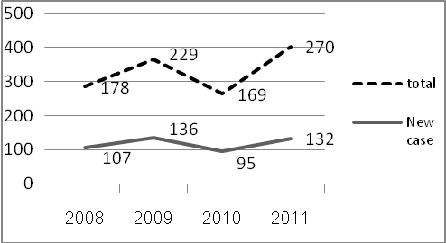

The enrolled population varied in each age group Almost 60% were 40 to 70 years old. There were 258 males (54.9%). Hypertension, diabetes mellitus and coronary artery disease were the most co-morbid conditions associated with the population (Table 1).

**Table 1** Selected characteristics of the patient population

|  |  |
| --- | --- |
|  | **N (%)** |
| Age |  |
| <40 | 56 (11.9) |
| 40-70 | 280 (59.6) |
| >70 | 134 (28.5) |
| Male gender | 258 (54.9) |
| Comorbid conditions |  |
| DM | 219 (46.6) |
| PAD | 9 (1.9) |
| CAD | 43 (9.1) |
| HT | 328 (69.8) |
| Othersa | 82 (17.4) |
| CrClb |  |
| <15 | 283 (60.2) |
| 15-30 | 32 (6.8) |

a other comorbid conditions: gout, CVA, cirrhosis, SLE, AAA, ADPKD

b missing data n=155 (33)

Of the 470 patients, 181 patients (39%) were referred from the nephrologists in Songklanagarind Hospital at PSU and 289 patients (61%) were referred from the surrounding hospitals in southern Thailand. Prior central venous catheter (CVC) placement presented at first visit in 205 (43.6%) patients and increased to 231 (49.1%) on the operation day. The average waiting time was 74 days. Only 39% of the patients referred from the nephrology service of Songklanagarind Hospital had prior CVC placement compared to 48% in patients referred from other hospitals (p < 0.01) (Figure 2).

**Figure 2** Prior CVC placement from non-PSU and PSU hospital; CVC: Central venous catheter, PSU: Songklanagarind Hospital.

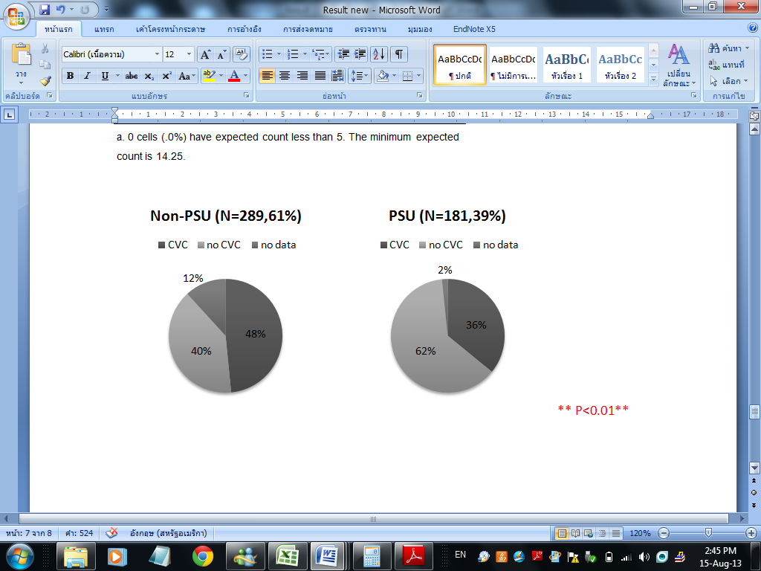

For the main results, AVF was performed in 337 patients (71.7%), of which the three most common sites were wrist radiocephalic, snuffbox and brachiocephalic. AVG was performed in 133 patients (28.3%) of which 96% were forearm AVG. The primary failure rates were 27.4% and 7.3% in the AVF and AVG groups, respectively (p<0.01). During the follow-up of an average 706 days, access-related complications occurred in 40.6% and 62.2% in the AVF and AVG groups, respectively (p<0.01). The most common complications were stenosis in the AVF group (67%) and thrombosis in the AVG group (51%). Infections were found in 0.9% and 6.3% in the AVF and AVG groups, respectively (p<0.01) (Table 2).

**Table 2** Patterns of permanent vascular access placement (N=470)

|  |  |  |  |
| --- | --- | --- | --- |
|  | **AVF**  **N (%)** | **AVG**  **N (%)** | **P-value a** |
| **Vascular access**  **Placement** | 337 (71.7) | 133 (28.3) | - |
| **Primary failure rate b** | 85 (27.4) | 9 (7.3) | <0.01* |
| Thrombosis | 11 (3.5) | 5 (4.1) | 0.81 |
| Stenosis | 16 (5.2) | - | <0.01* |
| Immature | 57 (18.4) | - | <0.01* |
| Infection | 1 (0.3) | 3 (2.4) | 0.04* |
| Steal syndrome | - | 1 (0.8) | 0.11 |
| **Complications c** | 88 (40.6) | 69 (62.2) | <0.01* |
| Thrombosis | 19 (8.8) | 35 (31.5) | <0.01* |
| Stenosis | 59 (27.2) | 16 (14.4) | <0.01* |
| Infection | 2 (0.9) | 7 (6.3) | <0.01* |
| Pseudoaneurysm | 5 (2.3) | 5 (4.5) | 0.27 |
| Steal syndrome | 2 (0.9) | 4 (3.6) | 0.09 |
| Anastamosis disruption | - | 1 (0.9) | 0.16 |
| Venous hypertension | 1(0.5) | - | 0.47 |
| Central vein stenosis | - | 1 (0.9) | 0.16 |
| **Times to detect first complication (mean, days)** | 464 | 413 | 0.39 |
| **Times to follow up**  **(mean, days) d** | 697 | 730 | 0.51 |

a P <0.05 is significant

b missing data 36 patients (N=434, AVF=310 , AVG=124)

c missing data 48 patients (N=422, AVF=302, AVG=120)

d missing data 27 patients (N=443, AVF=317, AVG=126)

In the AVF group, the two common access techniques were radiocephalic (48%) and snuffbox (19%) (Table 3). The main access-related problems included immaturation, thrombosis and stenosis. They were all higher in snuffbox compared with radiocephalic fistula and immaturation was significantly higher (Table 4).

**Table 3** Types of vascular access

|  |  |  |  |
| --- | --- | --- | --- |
| **AVF** | **N=337** | **AVG** | **N=133** |
| Radiocephalic | 226 (48.1) | Forearm | 128 (71.7) |
| Snuffbox | 89 (18.9) | Upper arm | 5 (27.2) |
| Brachiocephalic | 13 (2.8) |  |  |
| Brachioantecubital | 4 (0.9) |  |  |
| Ulnobasilic | 3 (0.6) |  |  |
| Radiobasilic | 1 (0.2) |  |  |
| Brachiobasilic | 1 (0.2) |  |  |

Data are presented as No. (%).

**Table 4** Comparison of problems of radiocephalic AVF vs snuffbox

|  |  |  |  |
| --- | --- | --- | --- |
|  | **Radiocephalic**  **N (%)** | **Snuffbox**  **N (%)** | **P-valuea** |
| Immature | 51 (24) | 27(38) | 0.02* |
| Thrombosis | 18 (9) | 10 (12.7) | 0.35 |
| Stenosis | 44 (21.9) | 24 (30.4) | 0.13 |
| Thrombosis + stenosis | 62 (30.9) | 34 (43.1) | 0.053 |

a P <0.05 is statistically significant

**Conclusion**

AVF is preferred to be the first initiated vascular access for suitable patients in Songklanagarind Hospital compatible with the 2006 K/DOQI guideline. However, the initial use of CVC in this study was too high. Even though the immaturation rate was high, AVF provides fewer and minor complications during follow-up compared to AVG.

**Acknowledgements**

The second author (P.C.) was supported by a research support grant from the Faculty of Medicine, Prince of Songkla University, Songkhla, Thailand. The authors thank Mr. Glen Kern Shing Ledecker of the Office of International Affairs of the Faculty of Medicine, Prince of Songkla University, for editing the manuscript for English usage.

**Conflict of interest**

The authors have no conflict of interest to declare.

**References**

1. National Kidney Foundation. KDOQI Clinical Practice Guidelines and Clinical Practice Recommendations for Vascular Access 2006. Am J Kidney Dis. 2006;48 (suppl 1):S176-S322.
2. Dhingra RK, Young EW, Hulbert-Shearon TE, Leavey SF, Port FK. Type of vascular access and mortality in U.S. hemodialysis patients. Kidney Int 2001; 60: 1443–1451
3. Pisoni RL, Young EW, Dykstra DM, et al: Vascular access use in Europe and the United States: Results from the DOPPS. Kidney Int 61:305–316, 2002.
4. Ethier J, Mendelssohn DC, Elder SJ, et al. Vascular access use and outcomes: an international perspective from the Dialysis Outcomes and Practice Patterns Study. Nephrol Dial Transplant.2008;23(10):3219-3226.
5. Young EW, Dykstra DM, Goodkin DA, et al: Hemodyalysis Vascular access preferences and outcomes in the Dialysis Outcomes and Practice Patterns Study (DOPPS). Kidney Int 61:2266-2271, 2002.
6. Xue JL, Dahl D, Ebben JP, Collins AJ: The association of initial hemodialysis access type with mortality outcomes in elderly Medicare ESRD patients. Am J Kidney Dis 42:1013–1019, 2003
7. Gonsalves CF, et al. Incidence of central vein stenosis and occlusion following upper extremity PICC and port placement. Cardiovasc Interv Radiol 26: 2003.
8. Abdullah BJ, et al. Incidence of upper limb venous thrombosis associated with peripherally inserted central catheters (PICC). Br J Radiol 78:596–600,2005.
9. Allen AW, et al. Venous thrombosis associated with the placement of peripherally inserted central catheters. J Vasc Interv Radiol 11:1309–1314, 2000.
10. Martin C, Viviand X, Saux P, Gouin F: Upper-extremity deep vein thrombosis after central venous catheterization via the axillary vein. Crit Care Med 27:2626–2629,1999.
11. Ivan D. Maya, MD, Rachel Oser, MD, Souheil Saddekni, MD, Jill Barker, PhD, and Michael Allon, MD. Vascular Access Stenosis: Comparison of Arteriovenous Grafts and Fistulas. American Journal of Kidney Diseases, Vol 44, No 5 (November), 2004: pp 859-865.
12. Stehman-Breen CO, Sherrard DJ, Gillen D, Caps M: Determinants of type and timing of initial permanent hemodialysis vascular access. Kidney Int 57:639-645, 2000
13. Allon M. Current management of vascular access. Clin J Am Soc Nephrol. 2007;2:786-800.
14. Fistula First Breakthrough Initiative. Fistula First data. Available at http://www.fistulafirst.org/AboutFistulaFirst/FFBIData.aspx. Accessed July 21, 2010.
15. European Best Practice Guidelines Expert Group on Hemodialysis, European Renal Association. Section I. Measurement of renal function, when to refer and when to start dialysis. Nephrol Dial Transplant 2002; 17 [Suppl 7]: 7–15