Supplemental data
Identification of genes targets for selected antipsychotics
GeneCards (https://genecards.org) and a database for searching genes of interests were used to identify genes targets for selected antipsychotics. Target genes of selected antipsychotics were identified using the name of 9 antipsychotics as a keyword. The keyword for searching in this step is “[compounds] ( Aripiprazole ) OR [compounds] ( Chlorpromazine ) OR [compounds] ( Fluphenazine ) OR [compounds] ( Haloperidol ) OR [compounds] ( Olanzapine ) OR [compounds] ( Quetiapine ) OR [compounds] ( Risperidone ) OR [compounds] ( Thiothixene ) OR [compounds] ( Ziprasidone )”.
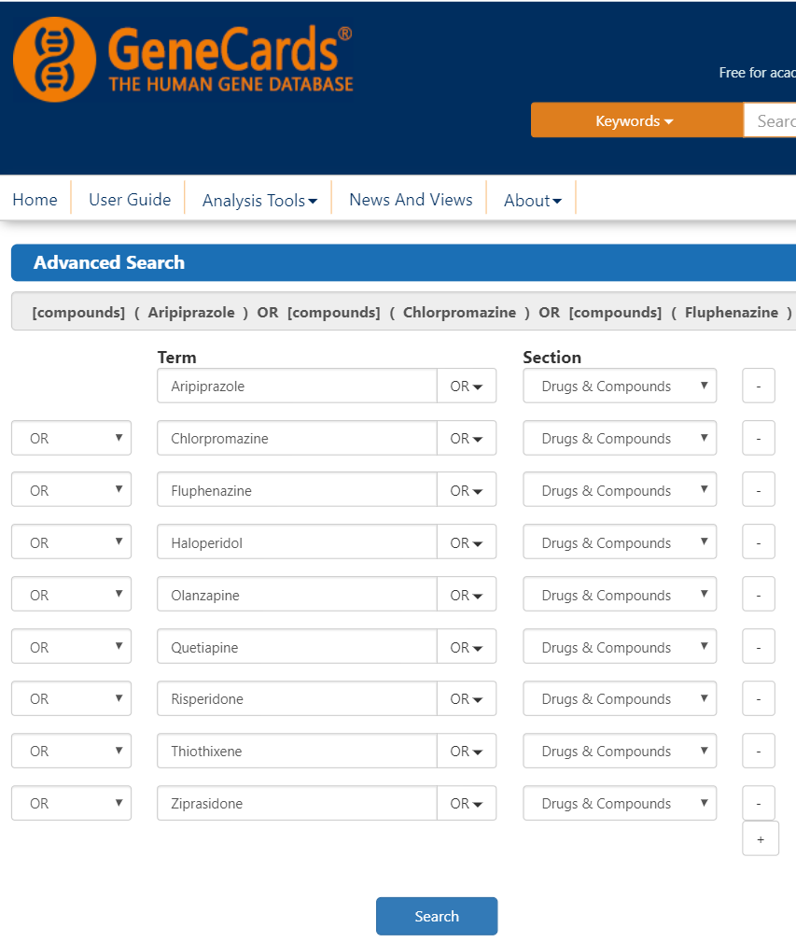
Figure S 1. A GeneCards keyword searching interface for identifying genes targets for antipsychotics
Identification gene associated with cognitive function in schizophrenia by Genecard Database
Genecard database was used to identify genes associated with cognitive function in schizophrenia. [publications] ( schizophrenia ) AND [disorders] ( schizophrenia ) AND [publications] ( cognitive ) AND [disorders] ( cognitive ) OR [functions] ( cognitive ) OR [pathways] ( cognitive ) is the keyword for searching in this step.
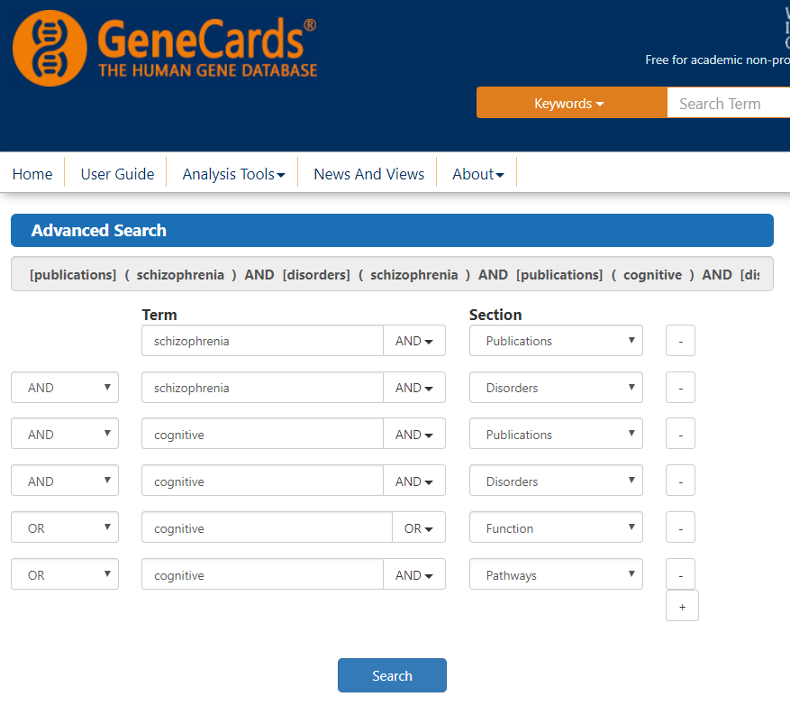
Figure S 2. A GeneCards keyword searching window for identifying gene associated with cognitive function in schizophrenia
Identification gene associated with cognitive function in schizophrenia by WebGestalt Database
The gene associated with cognitive function in schizophrenia were identified by WebGestalt Database (http://www.webgestalt.org/), which stands for WEB-based GEne SeT AnaLysis Toolkit. Over-representation analysis (ORA) is a method used in this study. Submission data in each parameter shown in Figure 12. The upload gene list is derived from the previous step, identification of genes targets for antipsychotics, which consist of 233 genes in the list.
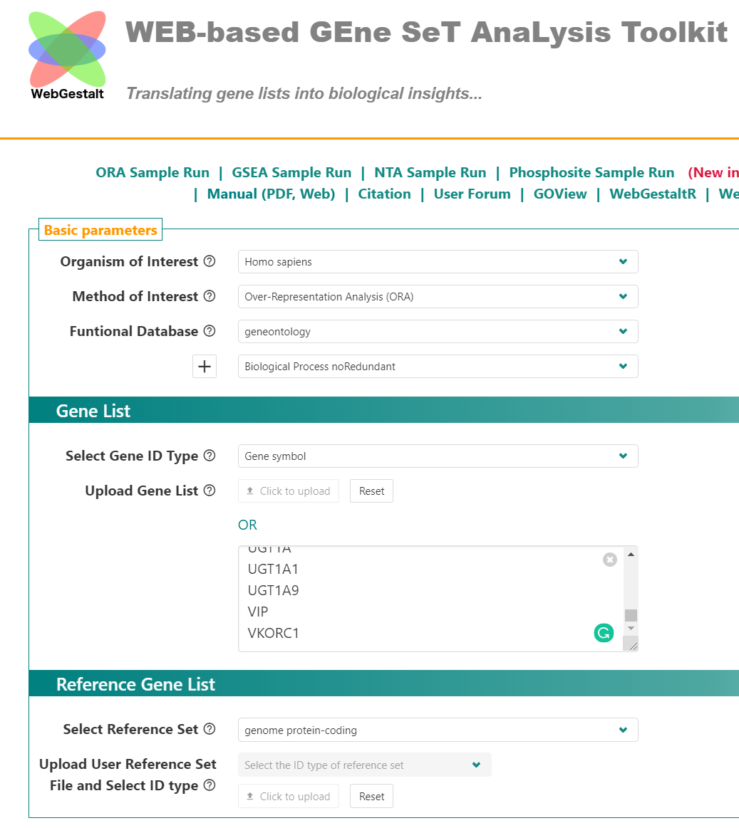
Figure S 3. WebGestalt submission user interface
Identification of gene associated with antipsychotics and cognitive function in schizophrenia
This step is a consequence step of step 4.2 (identification of genes targets for selected antipsychotics) and step 4.3 (identification gene associated with cognitive function in schizophrenia by Genecard Database). Gene findings from the previous step were condition formatting then filtered by matching in both terms of antipsychotics and cognitive function in schizophrenia. The following Figure shows step by step data condition formatting and filtering data in Microsoft Excel using to find common genes between two gene lists.
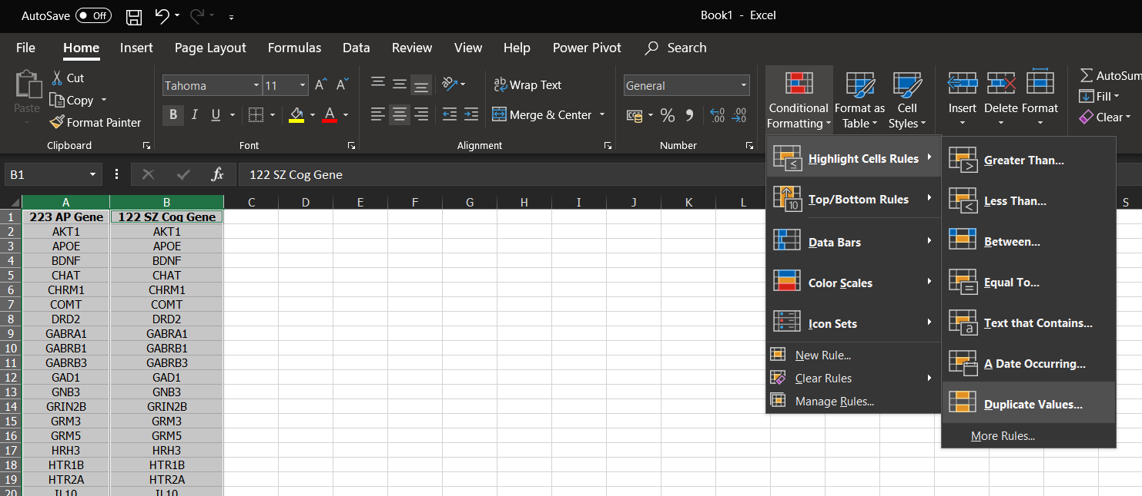
Figure S 4. Data Condition formatting in Microsoft Excel. Select the data column > Conditional formatting in home ribbon > Highlight cell rule > Duplicate Values
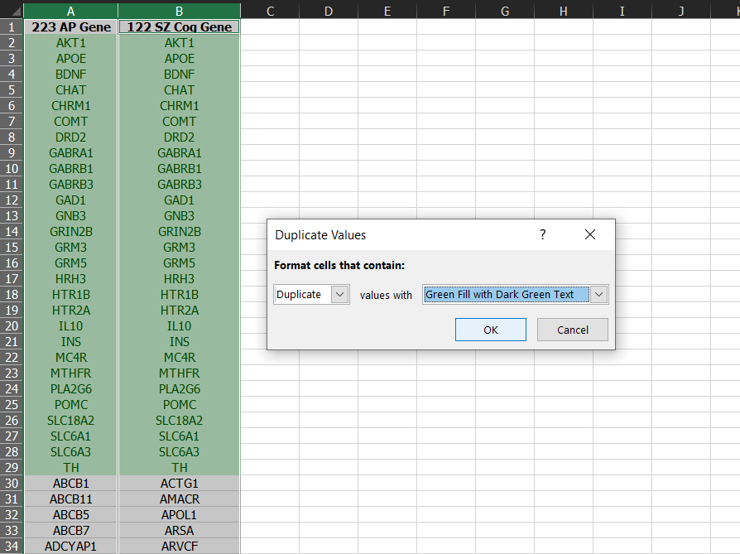
Figure S 5. Data Condition formatting in Microsoft Excel (Continuous). Select OK to apply selected format cells to the data
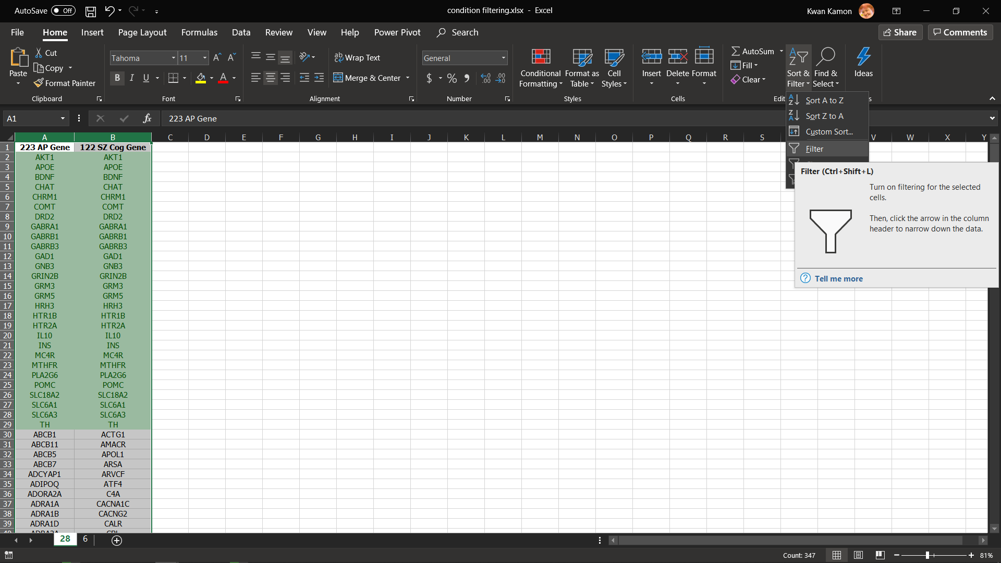
Figure S 6. Filtering data in Microsoft Excel. Select the data column > Sort & Filter in home ribbon > Filter to apply filter dropdown icon to selected columns

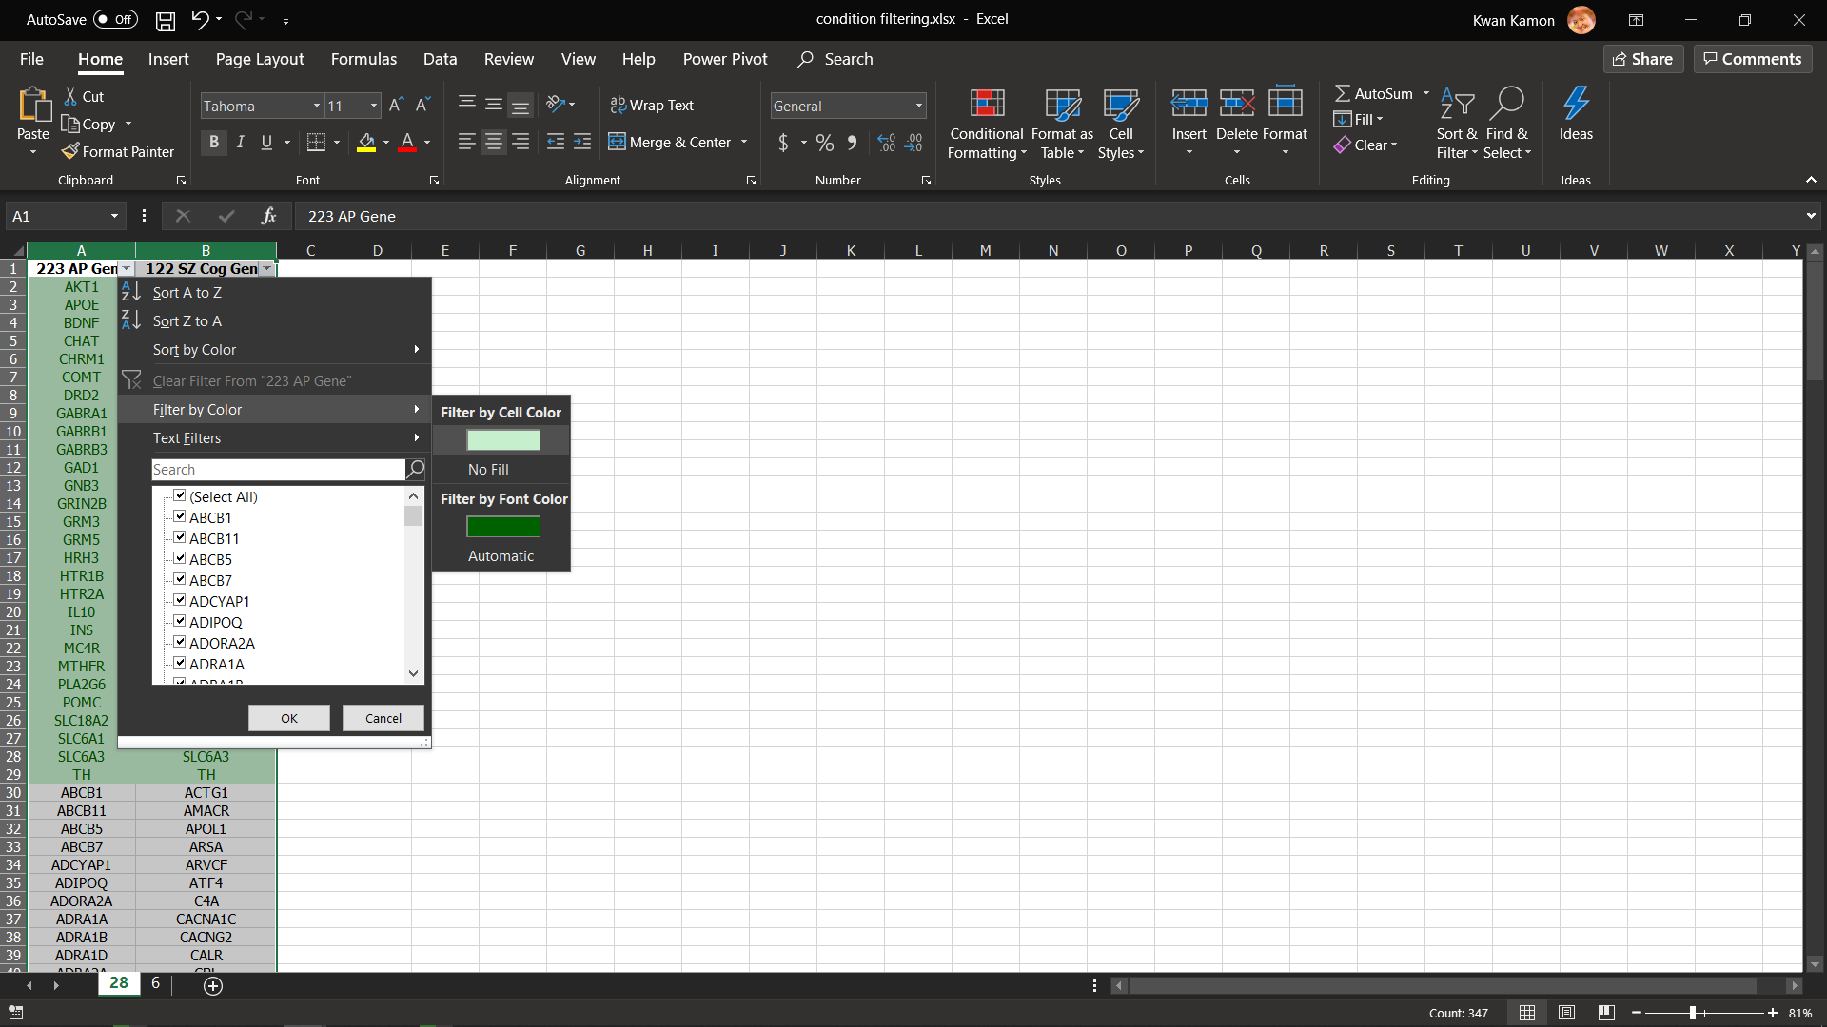
Figure S 7. Filtering data in Microsoft Excel (Continuous). Select filter dropdown icon in the top of the column > Filler by Color to filter data by format cell type
Protein-protein interactions network analysis
The gene list from the previous step (4.5) was further analyzed to identify protein-protein interactions and construct a protein-protein interactions network using STRING database.
Step to identify protein-protein interactions of the gene of interest start with
- Input list of the gene of interest name into multiple proteins search box and then select auto-detect organism and search (Figure 17).
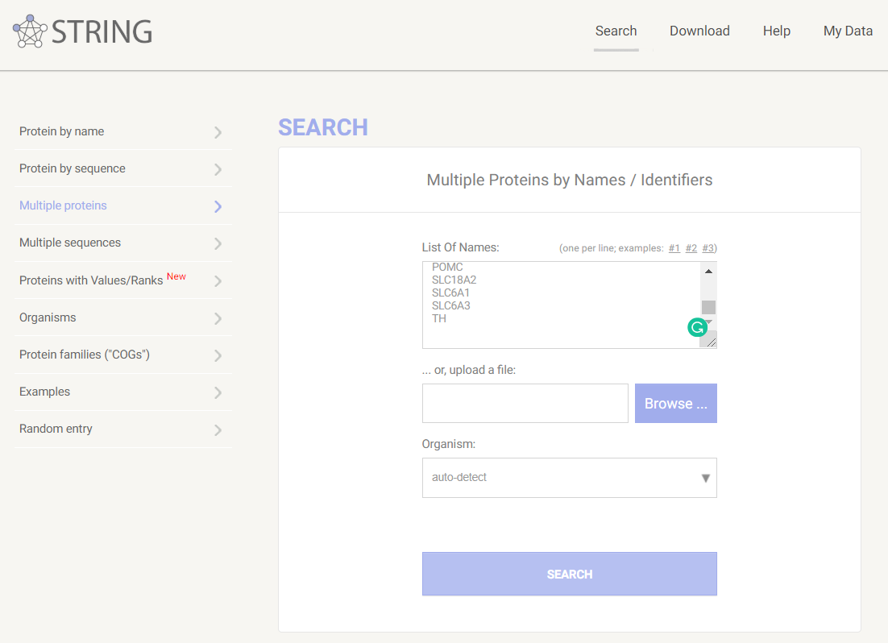
Figure S 8. Keyword searching interface of STRING database for construct Protein-protein interaction network
- The input of the Gene list might appear in several organisms. Homo sapiens organism was selected from the list and then pressed “continue” (Figure 18).
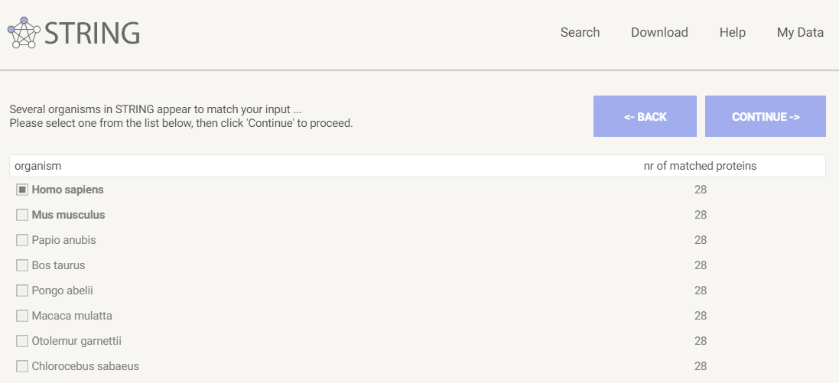
Figure S 9. Confirming the type of organism for input gene
- Many proteins in Homo sapiens might similar to input data. The matching protein was selected and then clicked continue (Figure 19).
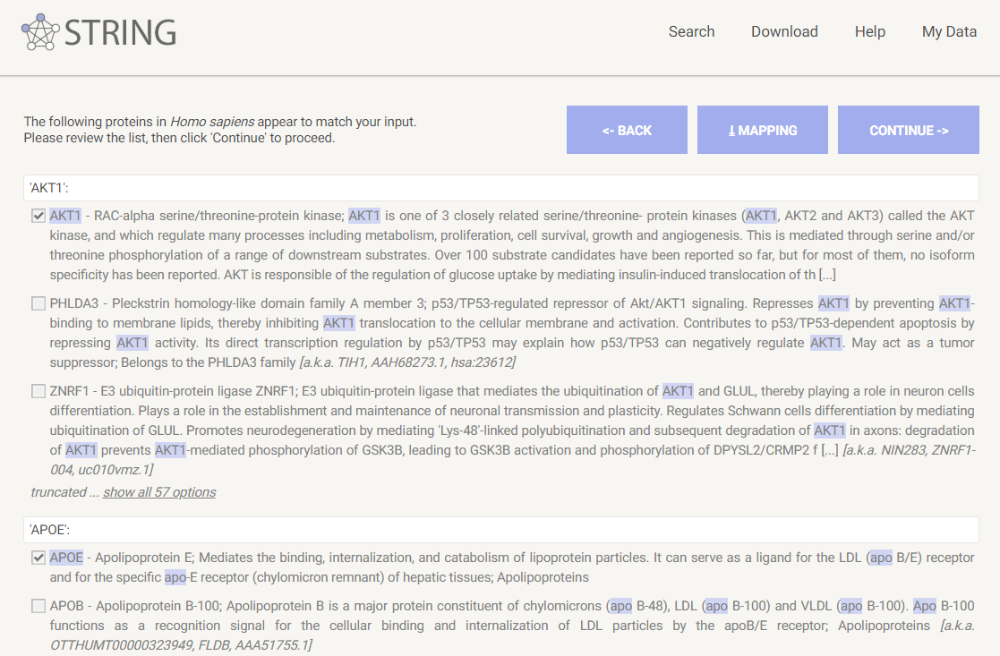
Figure S 10. Confirming protein name for input gene
- Protein-protein interactions network was generated and visualized only connected nodes in interaction evidence mode using three interaction sources: experiment, database and co-expression. The default setting was applied in minimum required interaction score, max number of interactions to show and network display mode (Figure 20).
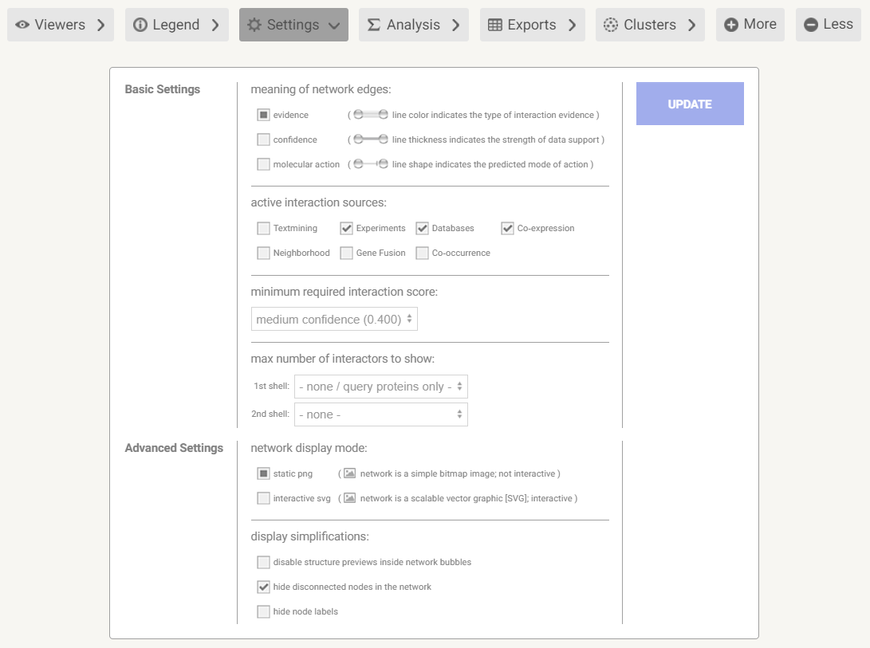
Figure S 11. Protein-protein interaction network setting
Network clustering
The network was clustered using the Markov Clustering method (MCL), with three inflation parameters to establish the most interconnected cluster of the PPI network.
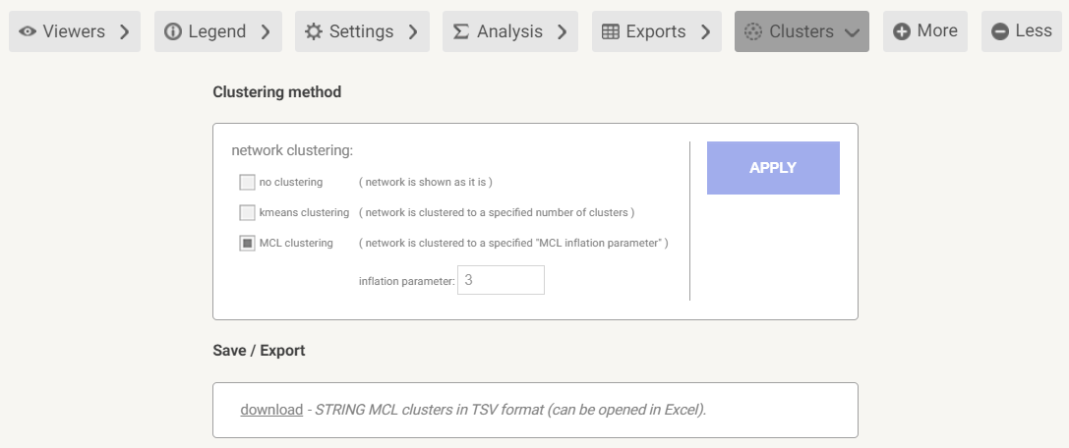
Figure S 12. Protein-protein interaction network clustering setting
Identification of a common gene that associated with antipsychotics and cognitive function in schizophrenia from deference two method
Gene findings from the WebGestalt and network clustering were condition formatting then filtered by matching gene of two lists. Figure 22 shows data condition formatting and filtering data setting in Microsoft Excel that were used to find common genes between two gene lists.
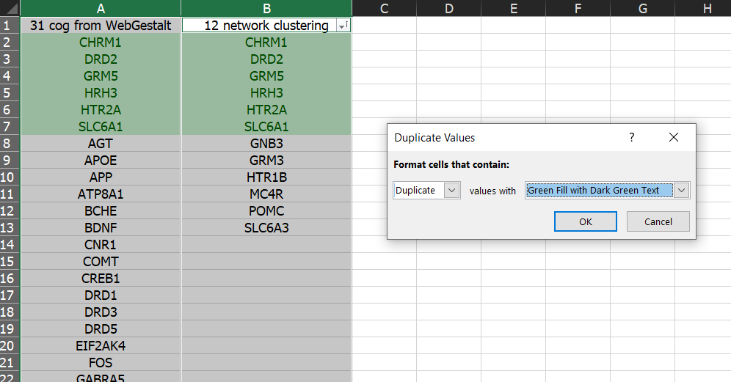
Figure S 13. Condition filtering to find a common gene that associated with antipsychotics and cognitive function in schizophrenia from deference two methods
Identification of pathway that contains potential protein involves antipsychotics and cognitive function in schizophrenia
The result from step 4.8 (identification of a common gene that associated with antipsychotics and cognitive function in schizophrenia from deference two methods) were used to identify the related pathway by STRING database. The results of the related pathway were shown in functional enrichment in the section of analysis (Figure 24).
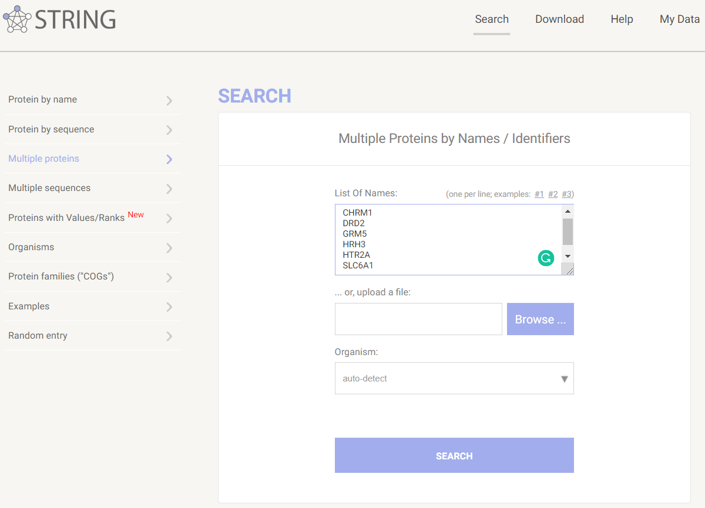
Figure S 14. Input data for identification of pathway contains potential protein involves antipsychotics and cognitive function in schizophrenia
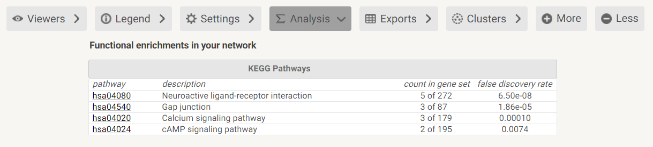
Figure S 15. KEGG pathways data in functional enrichment analysis

Table S1. Gene symbol and description of gene targets for selected antipsychotics
No. | Gene Symbol | Description
1 | ABCB1 | ATP Binding Cassette Subfamily B Member 1
2 | ABCB11 | ATP Binding Cassette Subfamily B Member 11
3 | ABCB5 | ATP Binding Cassette Subfamily B Member 5
4 | ABCB7 | ATP Binding Cassette Subfamily B Member 7
5 | ADCYAP1 | Adenylate Cyclase Activating Polypeptide 1
6 | ADIPOQ | Adiponectin, C1Q And Collagen Domain Containing
7 | ADORA2A | Adenosine A2a Receptor
8 | ADRA1A | Adrenoceptor Alpha 1A
9 | ADRA1B | Adrenoceptor Alpha 1B
10 | ADRA1D | Adrenoceptor Alpha 1D
11 | ADRA2A | Adrenoceptor Alpha 2A
12 | ADRA2B | Adrenoceptor Alpha 2B
13 | ADRA2C | Adrenoceptor Alpha 2C
14 | ADRB1 | Adrenoceptor Beta 1
15 | ADRB2 | Adrenoceptor Beta 2
16 | ADRB3 | Adrenoceptor Beta 3
17 | AGT | Angiotensinogen
18 | AGTR1 | Angiotensin II Receptor Type 1
19 | AHR | Aryl Hydrocarbon Receptor
20 | AKR1A1 | Aldo-Keto Reductase Family 1 Member A1
21 | AKR1B1 | Aldo-Keto Reductase Family 1 Member B
22 | AKR1C1 | Aldo-Keto Reductase Family 1 Member C1
23 | AKT1 | AKT Serine/Threonine Kinase 1
24 | ALB | Albumin
25 | ANKK1 | Ankyrin Repeat And Kinase Domain Containing 1
26 | AOX1 | Aldehyde Oxidase 1
27 | APOB | Apolipoprotein B
28 | APOE | Apolipoprotein E
29 | APOH | Apolipoprotein H
30 | APP | Amyloid Beta Precursor Protein
31 | AQP2 | Aquaporin 2
32 | AR | Androgen Receptor
33 | ATP8A1 | ATPase Phospholipid Transporting 8A1
34 | BAS | Beta-Adrenergic Stimulation, Response To
35 | BCHE | Butyrylcholinesterase
36 | BDNF | Brain Derived Neurotrophic Factor
37 | CACNA1B | Calcium Voltage-Gated Channel Subunit Alpha1 B
38 | CALM1 | Calmodulin 1
39 | CAMK2G | Calcium/Calmodulin Dependent Protein Kinase II Gamma
40 | CBR1 | Carbonyl Reductase 1
41 | CCKAR | Cholecystokinin A Receptor
42 | CCKBR | Cholecystokinin B Receptor
43 | CCL2 | C-C Motif Chemokine Ligand 2
44 | CHAT | Choline O-Acetyltransferase
45 | CHGA | Chromogranin A
46 | CHKB | Choline Kinase Beta
47 | CHRM1 | Cholinergic Receptor Muscarinic 1
48 | CHRM2 | Cholinergic Receptor Muscarinic 2
49 | CHRM3 | Cholinergic Receptor Muscarinic 3
50 | CHRM4 | Cholinergic Receptor Muscarinic 4
51 | CHRM5 | Cholinergic Receptor Muscarinic 5
52 | CNP | 2',3'-Cyclic Nucleotide 3' Phosphodiesterase
53 | CNR1 | Cannabinoid Receptor 1
54 | COMT | Catechol-O-Methyltransferase
55 | CPQ | Carboxypeptidase Q
56 | CRAT | Carnitine O-Acetyltransferase
57 | CREB1 | CAMP Responsive Element Binding Protein 1
58 | CTNNB1 | Catenin Beta 1
59 | CYP11B2 | Cytochrome P450 Family 11 Subfamily B Member 2
60 | CYP1A1 | Cytochrome P450 Family 1 Subfamily A Member 1
61 | CYP1A2 | Cytochrome P450 Family 1 Subfamily A Member 2
62 | CYP2A6 | Cytochrome P450 Family 2 Subfamily A Member 6
63 | CYP2C19 | Cytochrome P450 Family 2 Subfamily C Member 19
64 | CYP2C9 | Cytochrome P450 Family 2 Subfamily C Member 9
65 | CYP2D6 | Cytochrome P450 Family 2 Subfamily D Member 6
66 | CYP2E1 | Cytochrome P450 Family 2 Subfamily E Member 1
67 | CYP3A4 | Cytochrome P450 Family 3 Subfamily A Member 4
68 | CYP3A43 | Cytochrome P450 Family 3 Subfamily A Member 43
69 | CYP3A5 | Cytochrome P450 Family 3 Subfamily A Member 5
70 | CYP3A7 | Cytochrome P450 Family 3 Subfamily A Member 7
71 | DCN | Decorin
72 | DHDH | Dihydrodiol Dehydrogenase
73 | DNM3 | Dynamin 3
74 | DRD1 | Dopamine Receptor D1
75 | DRD2 | Dopamine Receptor D2
76 | DRD3 | Dopamine Receptor D3
77 | DRD4 | Dopamine Receptor D4
78 | DRD5 | Dopamine Receptor D5
79 | DTNBP1 | Dystrobrevin Binding Protein 1
80 | EGR1 | Early Growth Response 1
81 | EIF2AK4 | Eukaryotic Translation Initiation Factor 2 Alpha Kinase 4
82 | EPM2A | EPM2A Glucan Phosphatase, Laforin
83 | F10 | Coagulation Factor X
84 | FAAH | Fatty Acid Amide Hydrolase
85 | FASN | Fatty Acid Synthase
86 | FMO1 | Flavin Containing Monooxygenase 1
87 | FMO3 | Flavin Containing Monooxygenase 3
88 | FOS | Fos Proto-Oncogene, AP-1 Transcription Factor Subunit
89 | GABRA1 | Gamma-Aminobutyric Acid Type A Receptor Alpha1 Subunit
90 | GABRA2 | Gamma-Aminobutyric Acid Type A Receptor Alpha2 Subunit
91 | GABRA3 | Gamma-Aminobutyric Acid Type A Receptor Alpha3 Subunit
92 | GABRA4 | Gamma-Aminobutyric Acid Type A Receptor Alpha4 Subunit
93 | GABRA5 | Gamma-Aminobutyric Acid Type A Receptor Alpha5 Subunit
94 | GABRA6 | Gamma-Aminobutyric Acid Type A Receptor Alpha6 Subunit
95 | GABRB1 | Gamma-Aminobutyric Acid Type A Receptor Beta1 Subunit
96 | GABRB2 | Gamma-Aminobutyric Acid Type A Receptor Beta2 Subunit
97 | GABRB3 | Gamma-Aminobutyric Acid Type A Receptor Beta3 Subunit
98 | GABRD | Gamma-Aminobutyric Acid Type A Receptor Delta Subunit
99 | GABRE | Gamma-Aminobutyric Acid Type A Receptor Epsilon Subunit
100 | GABRG1 | Gamma-Aminobutyric Acid Type A Receptor Gamma1 Subunit
101 | GABRG2 | Gamma-Aminobutyric Acid Type A Receptor Gamma2 Subunit
102 | GABRG3 | Gamma-Aminobutyric Acid Type A Receptor Gamma3 Subunit
103 | GABRP | Gamma-Aminobutyric Acid Type A Receptor Pi Subunit
104 | GABRQ | Gamma-Aminobutyric Acid Type A Receptor Theta Subunit
105 | GAD1 | Glutamate Decarboxylase 1
106 | GCG | Glucagon
107 | GGT1 | Gamma-Glutamyltransferase 1
108 | GHRL | Ghrelin And Obestatin Prepropeptide
109 | GIPR | Gastric Inhibitory Polypeptide Receptor
110 | GLP1R | Glucagon Like Peptide 1 Receptor
111 | GLUD1 | Glutamate Dehydrogenase 1
112 | GNB3 | G Protein Subunit Beta 3
113 | GPT | Glutamic--Pyruvic Transaminase
114 | GRID2 | Glutamate Ionotropic Receptor Delta Type Subunit 2
115 | GRIN2B | Glutamate Ionotropic Receptor NMDA Type Subunit 2B
116 | GRM3 | Glutamate Metabotropic Receptor 3
117 | GRM5 | Glutamate Metabotropic Receptor 5
118 | GRM7 | Glutamate Metabotropic Receptor 7
119 | GSTM3 | Glutathione S-Transferase Mu 3
120 | HCRT | Hypocretin Neuropeptide Precursor
121 | HRH1 | Histamine Receptor H1
122 | HRH2 | Histamine Receptor H2
123 | HRH3 | Histamine Receptor H3
124 | HRH4 | Histamine Receptor H4
125 | HSPA4 | Heat Shock Protein Family A (Hsp70) Member 4
126 | HTR1A | 5-Hydroxytryptamine Receptor 1A
127 | HTR1B | 5-Hydroxytryptamine Receptor 1B
128 | HTR1D | 5-Hydroxytryptamine Receptor 1D
129 | HTR1E | 5-Hydroxytryptamine Receptor 1E
130 | HTR1F | 5-Hydroxytryptamine Receptor 1F
131 | HTR2A | 5-Hydroxytryptamine Receptor 2A
132 | HTR2B | 5-Hydroxytryptamine Receptor 2B
133 | HTR2C | 5-Hydroxytryptamine Receptor 2C
134 | HTR3A | 5-Hydroxytryptamine Receptor 3A
135 | HTR3D | 5-Hydroxytryptamine Receptor 3D
136 | HTR4 | 5-Hydroxytryptamine Receptor 4
137 | HTR5A | 5-Hydroxytryptamine Receptor 5A
138 | HTR6 | 5-Hydroxytryptamine Receptor 6
139 | HTR7 | 5-Hydroxytryptamine Receptor 7
140 | IL10 | Interleukin 10
141 | IL18R1 | Interleukin 18 Receptor 1
142 | IL1A | Interleukin 1 Alpha
143 | IL1R1 | Interleukin 1 Receptor Type 1
144 | IL2RB | Interleukin 2 Receptor Subunit Beta
145 | IL4 | Interleukin 4
146 | IMPACT | Impact RWD Domain Protein
147 | INS | Insulin
148 | KCNH1 | Potassium Voltage-Gated Channel Subfamily H Member 1
149 | KCNH2 | Potassium Voltage-Gated Channel Subfamily H Member 2
150 | KCNJ3 | Potassium Voltage-Gated Channel Subfamily J Member 3
151 | KCNJ5 | Potassium Voltage-Gated Channel Subfamily J Member 5
152 | KRIT1 | KRIT1 Ankyrin Repeat Containing
153 | LEP | Leptin
154 | LEPQTL1 | Leptin, Serum Levels Of
155 | LEPR | Leptin Receptor
156 | MAOB | Monoamine Oxidase B
157 | MB | Myoglobin
158 | MC4R | Melanocortin 4 Receptor
159 | MCHR1 | Melanin Concentrating Hormone Receptor 1
160 | MMP1 | Matrix Metallopeptidase 1
161 | MMP3 | Matrix Metallopeptidase 3
162 | MTHFR | Methylenetetrahydrofolate Reductase
163 | NEU1 | Neuraminidase 1
164 | NPPA | Natriuretic Peptide A
165 | NPPB | Natriuretic Peptide B
166 | NPY | Neuropeptide Y
167 | NR1I2 | Nuclear Receptor Subfamily 1 Group I Member 2
168 | NR3C2 | Nuclear Receptor Subfamily 3 Group C Member 2
169 | NR4A1 | Nuclear Receptor Subfamily 4 Group A Member 1
170 | NTS | Neurotensin
171 | OPRM1 | Opioid Receptor Mu 1
172 | ORM1 | Orosomucoid 1
173 | ORM2 | Orosomucoid 2
174 | PIK3C2A | Phosphatidylinositol-4-Phosphate 3-Kinase Catalytic Subunit Type 2 Alpha
175 | PLA2G6 | Phospholipase A2 Group VI
176 | PMCH | Pro-Melanin Concentrating Hormone
177 | POMC | Proopiomelanocortin
178 | POR | Cytochrome P450 Oxidoreductase
179 | PPARG | Peroxisome Proliferator Activated Receptor Gamma
180 | PPIG | Peptidylprolyl Isomerase G
181 | PRL | Prolactin
182 | PVALB | Parvalbumin
183 | PYY | Peptide YY
184 | RABEP1 | Rabaptin, RAB GTPase Binding Effector Protein 1
185 | RABEP2 | Rabaptin, RAB GTPase Binding Effector Protein 2
186 | REN | Renin
187 | RGS4 | Regulator Of G Protein Signaling 4
188 | SCD | Stearoyl-CoA Desaturase
189 | SCT | Secretin
190 | SH2B1 | SH2B Adaptor Protein 1
191 | SIGMAR1 | Sigma Non-Opioid Intracellular Receptor 1
192 | SLC17A5 | Solute Carrier Family 17 Member 5
193 | SLC18A2 | Solute Carrier Family 18 Member A2
194 | SLC22A1 | Solute Carrier Family 22 Member 1
195 | SLC2A1 | Solute Carrier Family 2 Member 1
196 | SLC2A4 | Solute Carrier Family 2 Member 4
197 | SLC6A1 | Solute Carrier Family 6 Member 1
198 | SLC6A2 | Solute Carrier Family 6 Member 2
199 | SLC6A3 | Solute Carrier Family 6 Member 3
200 | SLC6A4 | Solute Carrier Family 6 Member 4
201 | SLC6A5 | Solute Carrier Family 6 Member 5
202 | SMPD1 | Sphingomyelin Phosphodiesterase 1
203 | SV2C | Synaptic Vesicle Glycoprotein 2C
204 | SYP | Synaptophysin
205 | TAAR6 | Trace Amine Associated Receptor 6
206 | TAC1 | Tachykinin Precursor 1
207 | TACR1 | Tachykinin Receptor 1
208 | TAS2R10 | Taste 2 Receptor Member 10
209 | TAS2R14 | Taste 2 Receptor Member 14
210 | TBC1D1 | TBC1 Domain Family Member 1
211 | TG | Thyroglobulin
212 | TH | Tyrosine Hydroxylase
213 | TPMT | Thiopurine S-Methyltransferase
214 | TRD | T Cell Receptor Delta Locus
215 | TRH | Thyrotropin Releasing Hormone
216 | TRPC5 | Transient Receptor Potential Cation Channel Subfamily C Member 5
217 | TSPO | Translocator Protein
218 | TUBB | Tubulin Beta Class I
219 | UGT1A | UDP Glucuronosyltransferase Family 1 Member A Complex Locus
220 | UGT1A1 | UDP Glucuronosyltransferase Family 1 Member A1
221 | UGT1A9 | UDP Glucuronosyltransferase Family 1 Member A9
222 | VIP | Vasoactive Intestinal Peptide
223 | VKORC1 | Vitamin K Epoxide Reductase Complex Subunit 1

Table S2. Gene symbol and description of a gene associated with cognitive function in schizophrenia from the Genecard database
No. | Gene Symbol | Description
1 | COMT | Catechol-O-Methyltransferase
2 | APOE | Apolipoprotein E
3 | BDNF | Brain Derived Neurotrophic Factor
4 | HTR2A | 5-Hydroxytryptamine Receptor 2A
5 | MTHFR | Methylenetetrahydrofolate Reductase
6 | PRODH | Proline Dehydrogenase 1
7 | CHRNA7 | Cholinergic Receptor Nicotinic Alpha 7 Subunit
8 | DRD2 | Dopamine Receptor D2
9 | NRXN1 | Neurexin 1
10 | SLC6A3 | Solute Carrier Family 6 Member 3
11 | NRG1 | Neuregulin 1
12 | AKT1 | AKT Serine/Threonine Kinase 1
13 | SHANK3 | SH3 And Multiple Ankyrin Repeat Domains 3
14 | SLC1A1 | Solute Carrier Family 1 Member 1
15 | PLA2G6 | Phospholipase A2 Group VI
16 | GRIN2B | Glutamate Ionotropic Receptor NMDA Type Subunit 2B
17 | MECP2 | Methyl-CpG Binding Protein 2
18 | SNCA | Synuclein Alpha
19 | MAOA | Monoamine Oxidase A
20 | NTRK2 | Neurotrophic Receptor Tyrosine Kinase 2
21 | GRIN2A | Glutamate Ionotropic Receptor NMDA Type Subunit 2A
22 | DISC2 | Disrupted In Schizophrenia 2
23 | SLC1A2 | Solute Carrier Family 1 Member 2
24 | DAO | D-Amino Acid Oxidase
25 | C4A | Complement C4A (Rodgers Blood Group)
26 | SLC18A2 | Solute Carrier Family 18 Member A2
27 | CACNA1C | Calcium Voltage-Gated Channel Subunit Alpha1 C
28 | TNF | Tumor Necrosis Factor
29 | GRIN1 | Glutamate Ionotropic Receptor NMDA Type Subunit 1
30 | MAG | Myelin Associated Glycoprotein
31 | LRRK2 | Leucine Rich Repeat Kinase 2
32 | TH | Tyrosine Hydroxylase
33 | MC4R | Melanocortin 4 Receptor
34 | ARVCF | ARVCF Delta Catenin Family Member
35 | GAD1 | Glutamate Decarboxylase 1
36 | NR4A2 | Nuclear Receptor Subfamily 4 Group A Member 2
37 | ZNF804A | Zinc Finger Protein 804A
38 | ERBB4 | Erb-B2 Receptor Tyrosine Kinase 4
39 | PCNT | Pericentrin
40 | GABRB1 | Gamma-Aminobutyric Acid Type A Receptor Beta1 Subunit
41 | GRM3 | Glutamate Metabotropic Receptor 3
42 | SNAP25 | Synaptosome Associated Protein 25
43 | GBA | Glucosylceramidase Beta
44 | IL10 | Interleukin 10
45 | GRM5 | Glutamate Metabotropic Receptor 5
46 | CHAT | Choline O-Acetyltransferase
47 | PAX6 | Paired Box 6
48 | NOTCH4 | Notch Receptor 4
49 | SLC6A1 | Solute Carrier Family 6 Member 1
50 | MED12 | Mediator Complex Subunit 12
51 | CHRNA4 | Cholinergic Receptor Nicotinic Alpha 4 Subunit
52 | PAFAH1B1 | Platelet Activating Factor Acetylhydrolase 1b Regulatory Subunit 1
53 | CNTNAP2 | Contactin Associated Protein Like 2
54 | MLC1 | Modulator Of VRAC Current 1
55 | INS | Insulin
56 | PSAP | Prosaposin
57 | SLC1A3 | Solute Carrier Family 1 Member 3
58 | HLA-DRB1 | Major Histocompatibility Complex, Class II, DR Beta 1
59 | HRH3 | Histamine Receptor H3
60 | GABRB3 | Gamma-Aminobutyric Acid Type A Receptor Beta3 Subunit
61 | EP300 | E1A Binding Protein P300
62 | CHRM1 | Cholinergic Receptor Muscarinic 1
63 | HTR1B | 5-Hydroxytryptamine Receptor 1B
64 | GRIN2C | Glutamate Ionotropic Receptor NMDA Type Subunit 2C
65 | GRM1 | Glutamate Metabotropic Receptor 1
66 | NGF | Nerve Growth Factor
67 | GAP43 | Growth Associated Protein 43
68 | NDUFV2 | NADH:Ubiquinone Oxidoreductase Core Subunit V2
69 | GRIA4 | Glutamate Ionotropic Receptor AMPA Type Subunit 4
70 | NDUFS4 | NADH:Ubiquinone Oxidoreductase Subunit S4
71 | GRIA3 | Glutamate Ionotropic Receptor AMPA Type Subunit 3
72 | HLA-DQB1 | Major Histocompatibility Complex, Class II, DQ Beta 1
73 | SLC6A9 | Solute Carrier Family 6 Member 9
74 | DLG3 | Discs Large MAGUK Scaffold Protein 3
75 | FAS | Fas Cell Surface Death Receptor
76 | GABBR1 | Gamma-Aminobutyric Acid Type B Receptor Subunit 1
77 | GRIK2 | Glutamate Ionotropic Receptor Kainate Type Subunit 2
78 | CYFIP1 | Cytoplasmic FMR1 Interacting Protein 1
79 | EHMT1 | Euchromatic Histone Lysine Methyltransferase 1
80 | CHRNB2 | Cholinergic Receptor Nicotinic Beta 2 Subunit
81 | CDK5 | Cyclin Dependent Kinase 5
82 | NHLRC1 | NHL Repeat Containing E3 Ubiquitin Protein Ligase 1
83 | KCNC1 | Potassium Voltage-Gated Channel Subfamily C Member 1
84 | MICB | MHC Class I Polypeptide-Related Sequence B
85 | VRK2 | VRK Serine/Threonine Kinase 2
86 | CHL1 | Cell Adhesion Molecule L1 Like
87 | SP4 | Sp4 Transcription Factor
88 | GNB3 | G Protein Subunit Beta 3
89 | TACR3 | Tachykinin Receptor 3
90 | CACNG2 | Calcium Voltage-Gated Channel Auxiliary Subunit Gamma 2
91 | MEGF10 | Multiple EGF Like Domains 10
92 | APOL1 | Apolipoprotein L1
93 | CIT | Citron Rho-Interacting Serine/Threonine Kinase
94 | GABRA1 | Gamma-Aminobutyric Acid Type A Receptor Alpha1 Subunit
95 | TGFB1 | Transforming Growth Factor Beta 1
96 | ARSA | Arylsulfatase A
97 | GNAL | G Protein Subunit Alpha L
98 | TLR4 | Toll Like Receptor 4
99 | DNMT1 | DNA Methyltransferase 1
100 | GIGYF2 | GRB10 Interacting GYF Protein 2
101 | TBX1 | T-Box 1
102 | TNFRSF1A | TNF Receptor Superfamily Member 1A
103 | POMC | Proopiomelanocortin
104 | PCDH15 | Protocadherin Related 15
105 | ATF4 | Activating Transcription Factor 4
106 | VPS35 | VPS35 Retromer Complex Component
107 | HARS | Histidyl-TRNA Synthetase
108 | FOXP2 | Forkhead Box P2
109 | HSPG2 | Heparan Sulfate Proteoglycan 2
110 | SYNE1 | Spectrin Repeat Containing Nuclear Envelope Protein 1
111 | AMACR | Alpha-Methylacyl-CoA Racemase
112 | IL2RA | Interleukin 2 Receptor Subunit Alpha
113 | LTA | Lymphotoxin Alpha
114 | OPA1 | OPA1 Mitochondrial Dynamin Like GTPase
115 | TENM4 | Teneurin Transmembrane Protein 4
116 | ACTG1 | Actin Gamma 1
117 | HLA-A | Major Histocompatibility Complex, Class I, A
118 | CBL | Cbl Proto-Oncogene
119 | CLTCL1 | Clathrin Heavy Chain Like 1
120 | RHO | Rhodopsin
121 | CALR | Calreticulin
122 | HLA-DRA | Major Histocompatibility Complex, Class II, DR Alpha
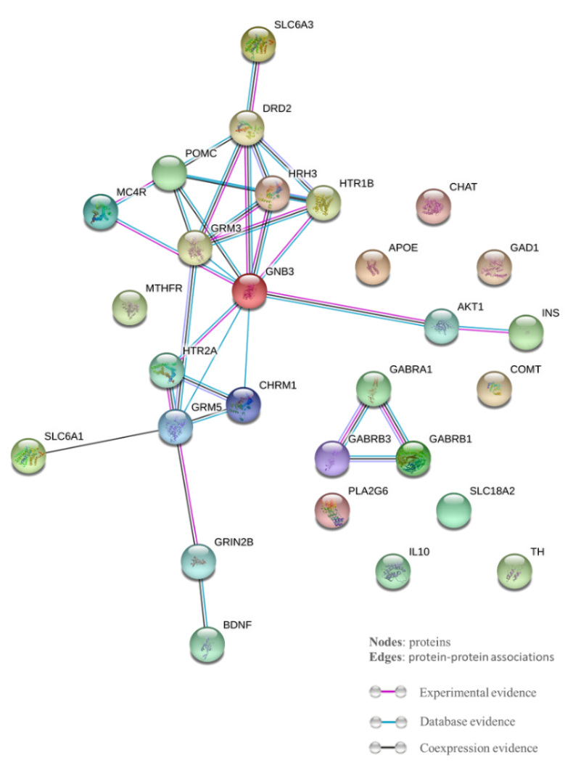
Figure 3A. Protein-protein interactions network of proteins associated with antipsychotics and cognitive function in schizophrenia. The protein-protein interaction is characterized by three different evidence including experimental, database or coexpression. Each evidence of protein-protein interaction is shown in a different color of the connecting line. The experimental, database or coexpression evidence is indicated in purple, blue and black lines, respectively.

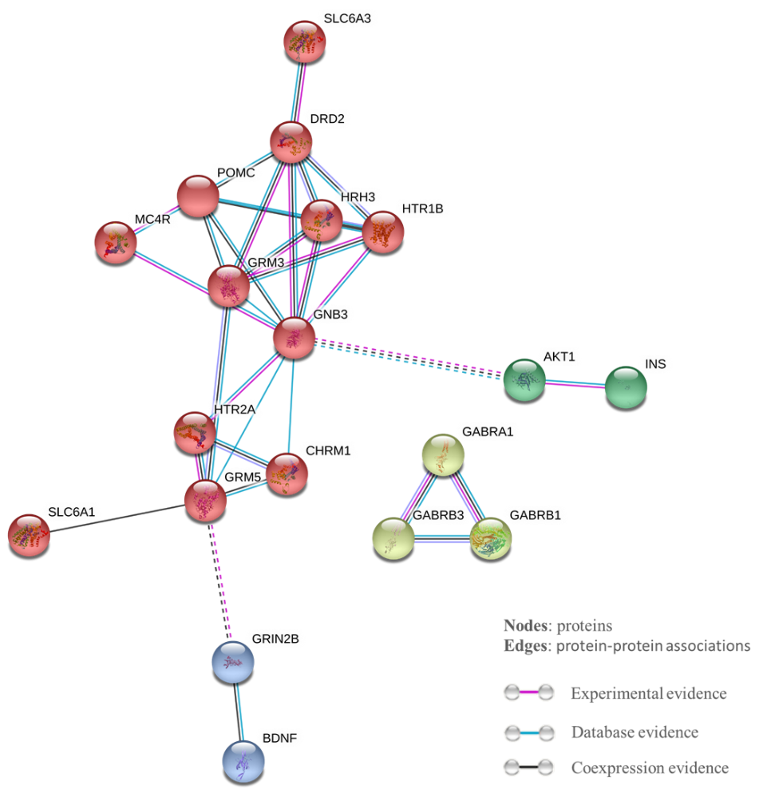
Figure 3B. Protein-protein interactions network of proteins associated with antipsychotics and cognitive function in schizophrenia after network clustering and hide disconnected nodes. The network clustering is indicated in color.

