Supplementary File
Genotoxicity and Cytotoxicity among Pesticide Exposed Workers: A Systematic Review and Meta-Analysis.
Table of contents

Registered Prospero Protocols | 1
Deviations from The Initial Protocols | 5
Supplementary Figure 1. Risk of Bias Assessment | 6
Study with High Risk of Bias | 7
Supplementary Table 1. Mean and Standard Deviations of Outcomes in Included Studies | 8
Supplementary Table 2. Characteristics of Pesticide Used in Included Studies | 10
Supplementary Figure 2. Sub-analysis based on gender in the pesticide exposed group | 18
Supplementary Figure 3. Sub-analysis based on smoking status in pesticide exposed group | 19
Supplementary Figure 4. Funnel plot and Egger’s test | 20
Supplementary Figure 5. Sensitivity test with leave one out analysis | 21
PRISMA Checklist | 23

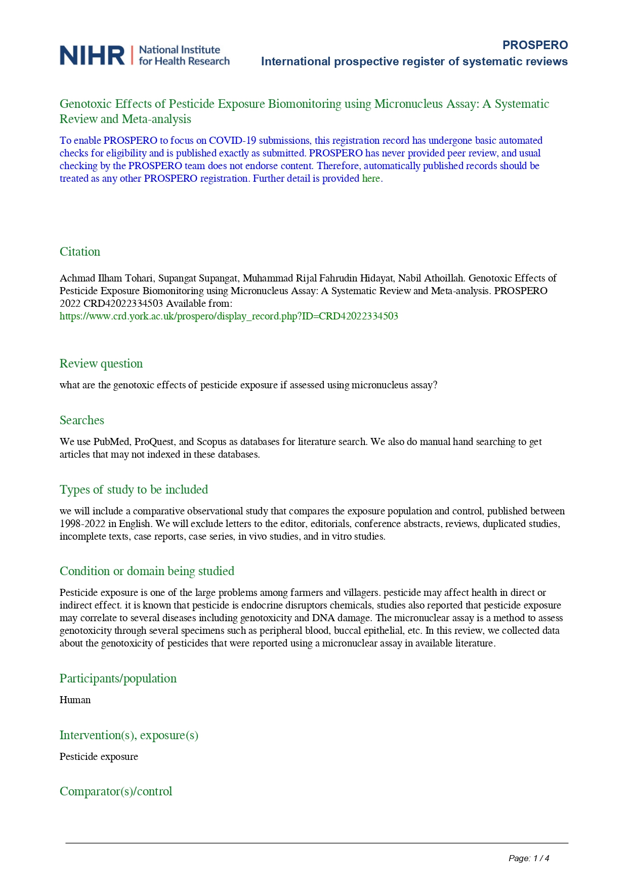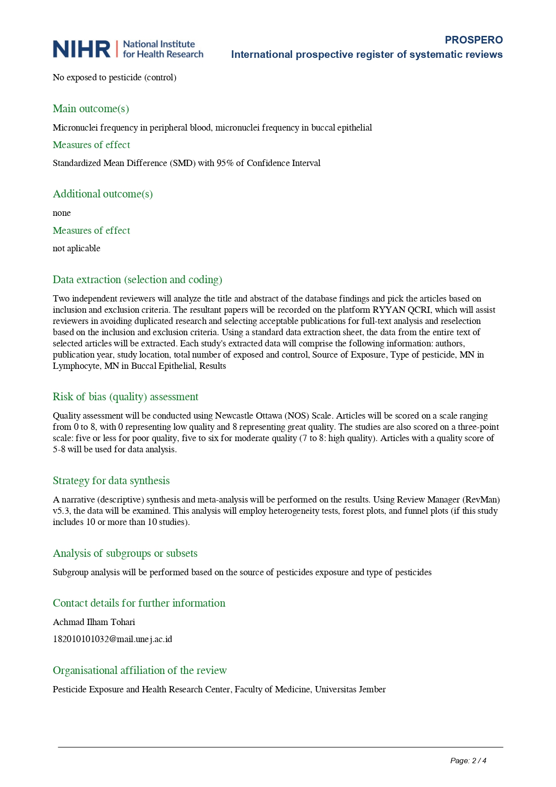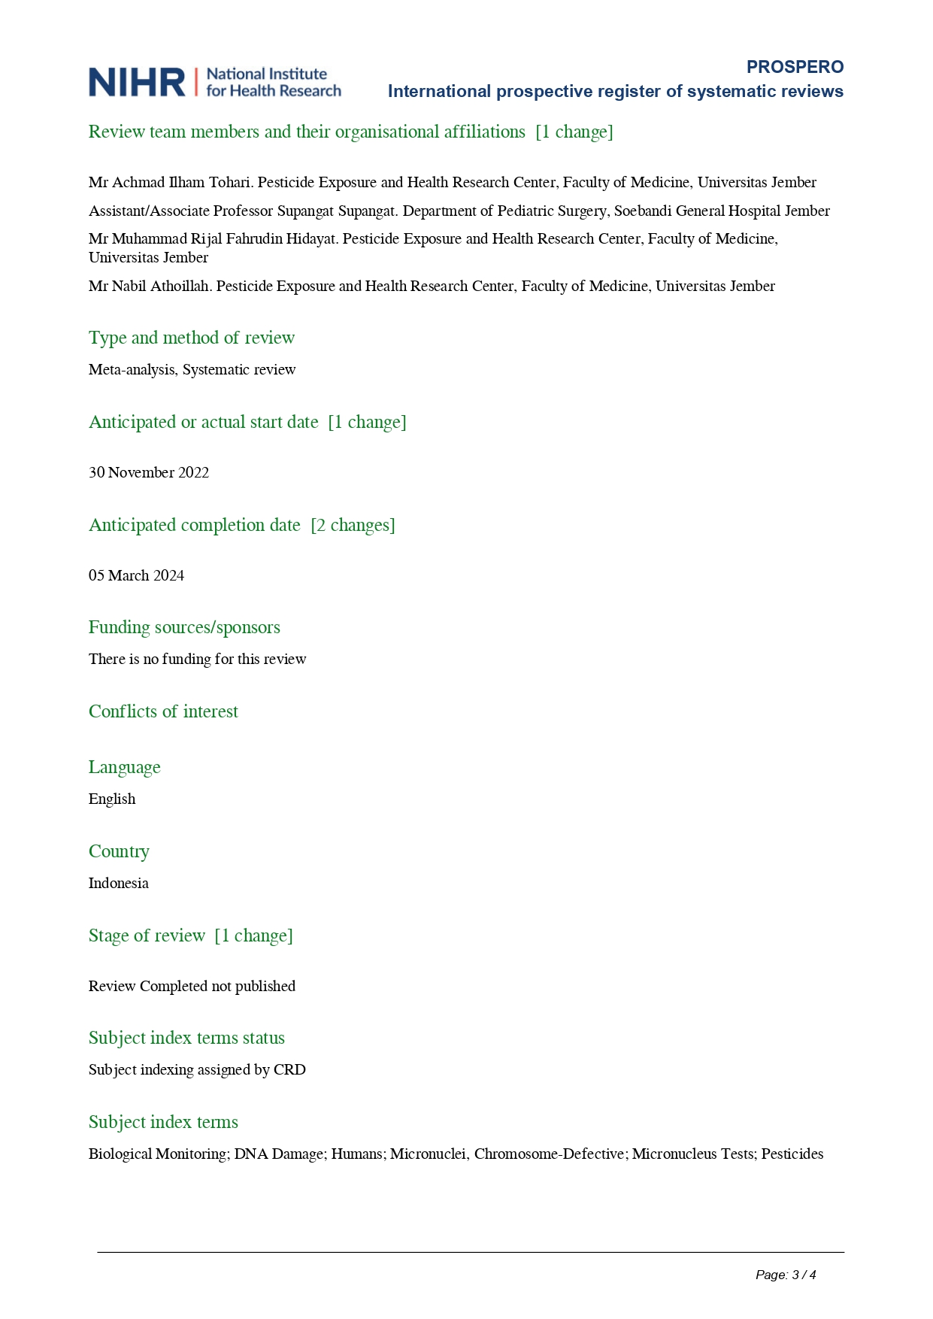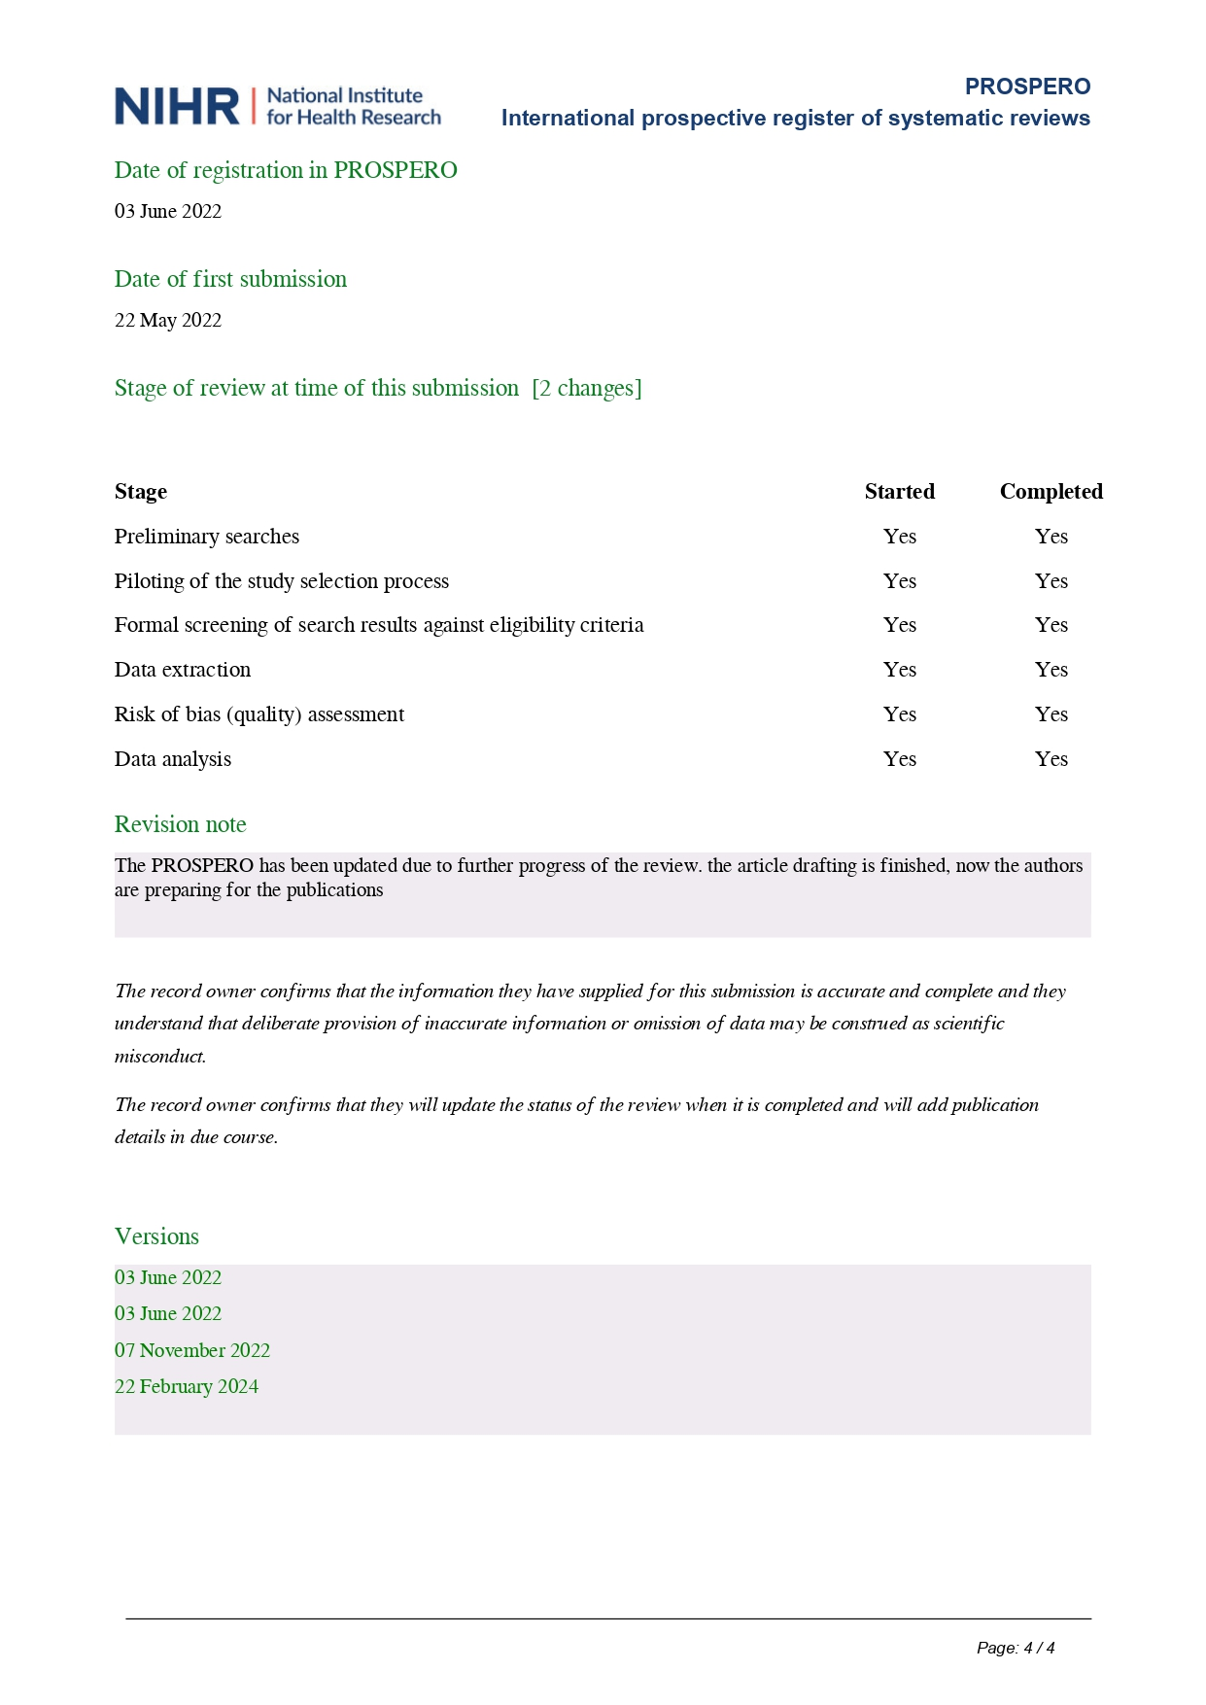

Deviations from The Protocol
No | Explanations
1. | Our first protocol stated that the outcome is just a micronucleus assay. However, after looking for many publications, we brought to the conclusion that micronucleus only is not enough for the genotoxicity and cytotoxicity assessment. We want to provide a broad evidence of pesticide exposure, thus we provide another outcome that can be measured through one same method with micronuclei that are binucleated cells and CBPI. To the best of our knowledge, no published meta-analysis combine micronucleus, binucleated cells, and CBPI also did the sub analysis based on region, gender, also smoking status.
2. | At the first protocol, we used many databases such as PubMed, Scopus, and ProQuest. In the present study we only used PubMed and Scopus because we were facing difficulty to import any data from ProQuest.
3. | We stated the range of study selection until 2022 in the initial protocol. Nevertheless, as the review continue until 2024, we broaden the range until January 2024 to get the latest evidence.
4. | We used NOS for quality assessment in the first protocol. However, in the present review we change the quality assessment to risk of bias assessment. Therefore, Risk of Bias in Non-Randomized Studies of Exposure (ROBINS-E) tools used.

Supplementary Figure 1. Risk of bias assessment
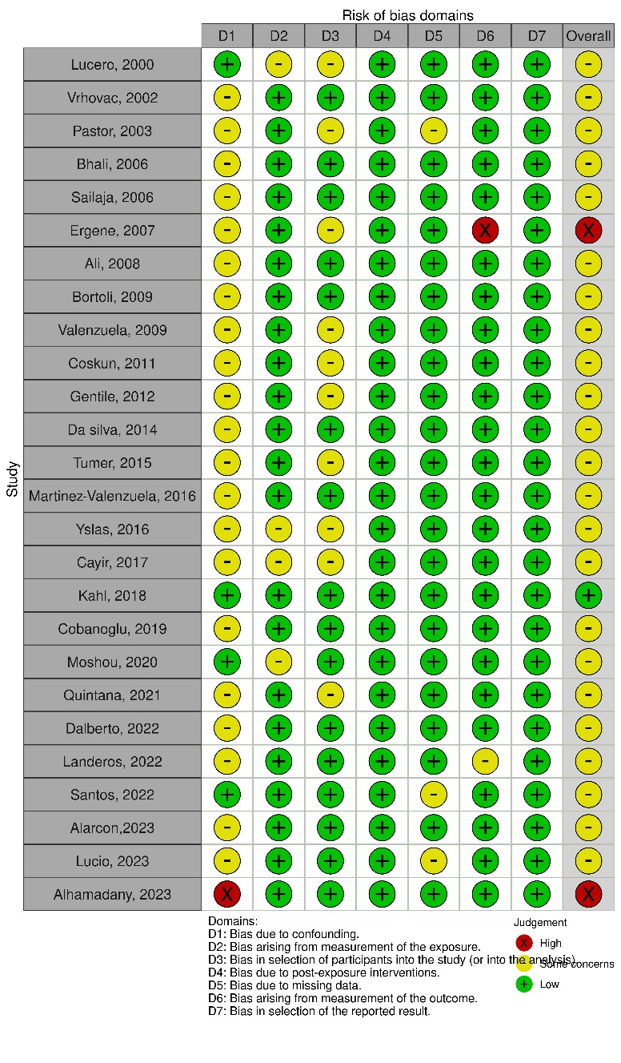
Risk of Bias for Each Studies
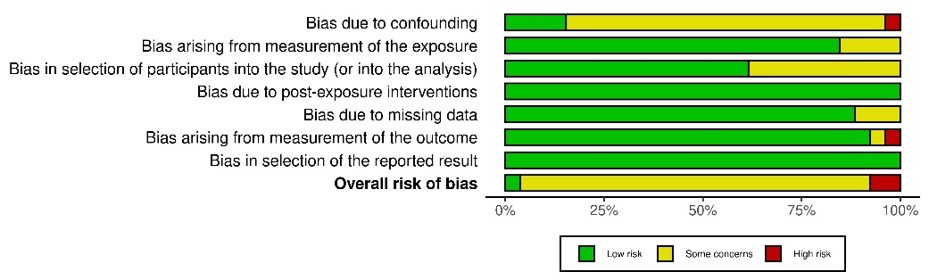
Overall Risk of Bias in Each Domain

Study with High Risk of Bias
Name of study: Ergene, 2007
Domain | Justification | Reason
Bias due to cofounding | Need concern | - There is no information about the residence of the control group  - Even the total number of smokers in each group is same, but the cigarette/ per day is significantly higher in exposed group
Bias from measurement of exposure | Low | - The exposure measurement using a questionnaire and demographic data  - The exposure time is same throughout the year and the exposure time is chronic
Bias in the selection participant | Need concern | - This study used purposive sampling
Bias due to post exposure intervention | Low | - The authors got the data in one time and there was no further intervention
Bias due to missing data | Low | - All outcomes mentioned in the paper
Bias from outcome measure | High | - There is a difference between the method section and the results regarding the cells observed. In methods, the author stated that the cells observed were 1000. However, the results stated that the cells observed were 3000
Bias in selective outcome | Low | - There was no evidence of selection outcome in this study

Ergene, S., Çelik, A., Çavaş, T., Kaya, F., 2007. Genotoxic biomonitoring study of population residing in pesticide contaminated regions in Göksu Delta: Micronucleus, chromosomal aberrations and sister chromatid exchanges. Environ Int 33, 877–885. https://doi.org/10.1016/j.envint.2007.04.003

Alhamadany, 2023
Domain | Justification | Reason
Bias due to cofounding | High | - There is no information about the confounding factor
Bias from measurement of exposure | Low | - The exposure measurement using a questionnaire
Bias in the selection participant | Low | - The participant's selection was based on the job
Bias due to post exposure intervention | Low | - The authors got the data in one time and there was no further intervention
Bias due to missing data | Low | - All outcomes mentioned in the paper
Bias from outcome measure | Low | - Outcome measurement was mentioned clearly in the method
Bias in selective outcome | Low | - There was no evidence of selection outcome in this study

Alhamadany, A.Y.M., Khalaf, S.D. and Alkateb, Y.N.M. (2023) ‘Genotoxicity and genomic instability in oral epithelial cells of agricultural workers exposed to pesticides using micronucleus and comet assay in Nineveh, Iraq’, Journal of Applied and Natural Science, 15(2), pp. 473–479. Available at: https://doi.org/10.31018/jans.v15i2.4329.

Supplementary Table 1. Mean and Standard Deviations of Outcomes in Included Studies
Study | Country | MNL |  |  |  |  | MNB |  |  |  |  | BNMN |  |  |  |  | BCMN |  |  |  |  | CBPI
 |  | n | Exposure | n | Control | Number of Cells | n | Exposure | n | Control | Number of Cells | n | Exposure | n | Control | Number of Cells | n | Exposure | n | Control | Number of cells | n | Exposure | n | Control | Number of Cells
Lucero, 2000 | Spain | 64 | 9,53 ± 6,904 | 50 | 7,90 ± 0,8839 | 1000 | 59 | 1,83 ± 0,9909 | 45 | 1,77 ± 0,8385 | 2000 | 64 | 9,53 ± 6,904 | 50 | 7,90 ± 0,8839 | 1000 |  |  |  |  |  | 64 | 1,86 ± 0,022 | 50 | 1,82 ± 0,025 | 500
Vrhovac, 2002 | Croatia | 10 | 30,5 ± 8,73 | 20 | 3,85 ± 1,6 | 500
pastor, 2003 | Greece, Spain, Poland, Hungary | 239 | 12,55 ± 8,5028 | 218 | 13,82 ± 10,1877 | 1000 | 228 | 1,03 ± 1,359 | 213 | 1,06 ± 1,4595 | 2000 | 239 | 11,40 ± 7,5752 | 218 | 12,25 ± 8,8589 | 1000 | 228 | 1,03 ± 1,359 | 213 | 1,06 ± 1,4595 | 1000 | 239 | 1,61 ± 0,1546 | 218 | 1,72 ± 0,1476 | 500
bhalli, 2006 | Pakistan | 29 | 20,41 ± 4,63 | 35 | 9,03 ± 2,46 | 1000 |  |  |  |  |  | 29 | 12,62 ± 1,47 | 35 | 6,11 ± 1,95 | 1000 |  |  |  |  |  | 29 | 1,26 ± 0,21 | 35 | 1,71 ± 0,26 | 500
sailaja, 2006 | India |  |  |  |  |  | 54 | 1,24 ± 0,72 | 54 | 0,32 ± 0,26 | 2000
Ergene, 2007 | Turkey |  |  |  |  |  | 32 | 2,36 ± 0.31 | 32 | 2,00 ± 0,78
ali, 2008 | Pakistan | 69 | 16,51 ± 4,27 | 69 | 5,86 ± 3,09 | 1000 |  |  |  |  |  | 69 | 12,72 ± 3,48 | 69 | 4,35 ± 2,44 | 1000 |  |  |  |  |  | 69 | 1,57 ± 0,37 | 69 | 2,41 ± 0,74 | 500
bortoli, 2009 | Brazil |  |  |  |  |  | 29 | 3,55 ± 2,13 | 37 | 1,70 ± 1,23 | 1000
martinez-valenzuela, 2009 | Mexico |  |  |  |  |  | 70 | 2,83 ± 2,9283 | 70 | 0,37 ± 0,8367 | 3000 |  |  |  |  |  | 70 | 2,09 ± 1,004 | 70 | 0,71 ± 0,6693 | 3000
Coskun, 2011 | Turkey | 46 | 10,3 ± 7,3927 | 48 | 4,84 ± 4,1569 | 1000 | 46 | 8,47 ± 5,2902 | 48 | 4,10 ± 3,8105 | 1000 |  |  |  |  |  |  |  |  |  |  | 46 | 1,56 ± 0,3391 | 48 | 1,65 ± 0,7621 | 500
Gentile, 2012 | Argentina | 20 | 16,6 ± 5,66 | 10 | 7,4 ± 1,35 | 1000 |  |  |  |  |  | 20 | 15,15 ± 5,1 | 10 | 7,2 ± 1,55 | 1000 |  |  |  |  |  | 20 | 1,26 ± 0,07 | 10 | 1,24 ± 0,03 | 500
da silva, 2014 | Brazil | 30 | 8,88 ± 5,30 | 30 | 6,19 ± 3,55 | 2000
tumer, 2015 | Turkey | 58 | 8,97 ± 3,7317 | 58 | 2,64 ± 1,3708 | 2000
martinez-valenzuela,2016 | Mexico |  |  |  |  |  | 30 | 6,1 ± 2,1909 | 30 | 1,7 ± 2,1909 | 1000 |  |  |  |  |  | 30 | 107,8 ± 121,5944 | 30 | 0,4 ± 1,0954 | 1000
Yslas, 2016 | Mexico |  |  |  |  |  | 37 | 4,5 ± 5,5 | 34 | 0,7 ± 0,9 | 2000 |  |  |  |  |  | 37 | 3,1 ± 2,9 | 34 | 2,6 ± 2,1 | 2000
cayir, 2017 | Turkey | 68 | 13,3 ± 7,79 | 43 | 9,39 ± 4,44 | 2000 | 68 | 11,76 ± 6,82 | 43 | 8,56 ± 3,91 | 2000 |  |  |  |  |  |  |  |  |  |  | 68 | 1,72 ± 0,17 | 43 | 1,64 ± 0,18 | 1000
kahl, 2018 | Brazil | 40 | 6,0 ± 3,7317 | 40 | 2,9 ± 2,5298 | 1000 |  |  |  |  |  | 40 | 120,6 ± 53,1263 | 40 | 61,3 ± 51,8614 | 500
cobanoglu, 2019 | Turkey |  |  |  |  |  | 66 | 3,55 ± 2,95 | 50 | 2,28 ± 2,24 | 1000 |  |  |  |  |  | 66 | 11,03 ± 7,30 | 50 | 7,68 ± 4,55 | 1000
Moshou, 2020 | Greece | 24 | 13,67 ± 6,3197 | 24 | 8,88 ± 3,4783 | 1000 | 24 | 12,46 ± 5,1439 | 24 | 8,50 ± 3,0374 | 1000 |  |  |  |  |  |  |  |  |  |  | 24 | 1,94 ± 0,2449 | 24 | 1,88 ± 0,147 | 2000
quintana, 2021 | Mexico | 54 | 7,53 ± 5,45 | 26 | 2,68 ± 4,35 | 1000 | 54 | 0,777 ± 1,39 | 26 | 0,269 ± 0,365 | 1000 |  |  |  |  |  | 54 | 8,754 ± 6,43 | 26 | 3,712 ± 2,069 | 1000
Dalberto, 2022 | Brazil |  |  |  |  |  | 84 | 2,02 ± 2,69 | 85 | 2,20 ± 2,28 | 2000 |  |  |  |  |  | 84 | 4,91 ± 2,62 | 85 | 4 ± 2,6 | 2000
Landeros, 2022 | Chile | 30 | 17,1 ± 4,9 | 30 | 4,2 ± 2,5 | 1000
Santos, 2022 | Brazil |  |  |  |  |  | 81 | 1,96 ± 2,13 | 81 | 0,94 ± 1,17 | 1000 |  |  |  |  |  | 81 | 1,88 ± 2,10 | 81 | 1,16 ± 1,25 | 1000
Alarcon, 2023 | Mexico |  |  |  |  |  | 42 | 10,14 ± 33,3758 | 46 | 2,40 ± 1,3565 | 1000 |  |  |  |  |  | 42 | 77,25 ± 50,8738 | 46 | 2,40 ± 1,8991 | 1000
Lucio, 2023 | Brazil |  |  |  |  |  | 23 | 0,87 ± 1,79 | 27 | 0,22 ± 0,85 | 2000 |  |  |  |  |  | 23 | 11,91 ± 9,35 | 27 | 9,19 ± 5,85 | 2000
Alhamadany, 2023 | Iraq |  |  |  |  |  | 100 | 4,12 ± 0,058 | 102 | 0,32 ± 0,097 | 100 |  |  |  |  |  | 100 | 0,392 ± 0,076 | 102 | 0,490 ± 0,069 | 100

Supplementary Table 2. Characteristics of Pesticide Used in Included Studies
No | Study | Country | Type of Participants |  | Type of Plant | Type of Pesticide
 |  |  | Exposure | Control |  | Group | Type | % (if any)
1 | Lucero, 2000 | Spain | Agricultural worker | Another job in the same area | NM | Insecticide | Abamectine | 35.90%
 |  |  |  |  |  |  | Acrinathrin | 17.20%
 |  |  |  |  |  |  | Buprofezin | 4.70%
 |  |  |  |  |  |  | Cyromazine | 12.50%
 |  |  |  |  |  |  | Dichlorvos | 3.20%
 |  |  |  |  |  |  | Endosulfan | 20.30%
 |  |  |  |  |  |  | Formetanate | 9.40%
 |  |  |  |  |  |  | Imadacloparid | 50%
 |  |  |  |  |  |  | Malathion | 12.40%
 |  |  |  |  |  |  | Methamidophos | 34.40%
 |  |  |  |  |  |  | Methomyl | 50%
 |  |  |  |  |  |  | Permethrin | 4.70%
 |  |  |  |  |  |  | Pyriproxyfen | 14.10%
 |  |  |  |  |  |  | Tabufenozide | 4.70%
 |  |  |  |  |  |  | Tralomethrin | 15.60%
 |  |  |  |  |  | Fungicides | Carbendazim | 3.10%
 |  |  |  |  |  |  | Cymoxanil | 14.10%
 |  |  |  |  |  |  | Diethofencarb | 3.10%
 |  |  |  |  |  |  | Mancozeb | 12.50%
 |  |  |  |  |  |  | Nuarimol | 3.10%
 |  |  |  |  |  |  | Fosetyl-aluminium | 6.20%
 |  |  |  |  |  |  | Procymidone | 10.90%
 |  |  |  |  |  |  | Propamocarb | 3.10%
 |  |  |  |  |  |  | Propineb | 7.80%
 |  |  |  |  |  | Bacterides | Kasugamycin | 4.70%
2 | Vrhovac, 2002 | Croatia | Pesticide production workers | General population that do not have history of pesticide exposure | NA | Herbicide | Atrazine | NM
 |  |  |  |  |  |  | Alachlor | NM
 |  |  |  |  |  |  | Cyanazine | NM
 |  |  |  |  |  | Insecticide | Malathion | NM
3 | pastor, 2003 | Greece, Spain, Poland, Hungary | Agricultural worker | Another job in another area | Vegetables | Insecticide used in Greece | Carbamate | 50.30%
 |  |  |  |  | Ornamental plant |  | Pyrethroid | 25.60%
 |  |  |  |  | Green house plant |  | Organophosphate | 47.20%
 |  |  |  |  |  | Bacterides used in Greece | Antibiotics (unspecified) | 2%
 |  |  |  |  |  | Insecticide used in Spain | Carbamate | 70.20%
 |  |  |  |  |  |  | Pyrethroid | 37.50%
 |  |  |  |  |  |  | Organophosphate | 56.30%
 |  |  |  |  |  | Bacterides used in Spain | Antibiotics (unspecified) | 40.60%
 |  |  |  |  |  | Insecticide used in Poland | Carbamate | 66%
 |  |  |  |  |  |  | Pyrethroid | 92%
 |  |  |  |  |  |  | Organophosphate | 56%
 |  |  |  |  |  | Bacterides used in Poland | Antibiotics (unspecified) | 4%
 |  |  |  |  |  | Insecticide used in Hungary | Carbamate | 40.20%
 |  |  |  |  |  |  | Pyrethroid | 82.70%
 |  |  |  |  |  |  | Organophosphate | 83.90%
4 | bhalli, 2006 | Pakistan | Pesticide production workers | Another job in the same area | NA | Insecticide | Organophosphate | NM
 |  |  |  |  |  |  | Pyrethroid | NM
5 | sailaja, 2006 | India | Pesticide production workers | General population (other job) | NA | Insecticide | Organophosphate | NM
 |  |  |  |  |  |  | Carbamate | NM
 |  |  |  |  |  |  | Pyrethroid | NM
6 | Ergene, 2007 | Turkey | Pesticide-exposed worker | Non-pesticide exposed worker | NM | Insecticide | Organochlorine | NM
 |  |  |  |  |  |  | Organophosphate | NM
 |  |  |  |  |  |  | Carbamate | NM
 |  |  |  |  |  |  | Pyrethroid | NM
 |  |  |  |  |  |  | Benzoyl urea | NM
7 | ali, 2008 | Pakistan | Cotton picking workers | Another job in other area | Cotton | Insecticide | Organophosphate | NM
 |  |  |  |  |  |  | Carbamate | NM
 |  |  |  |  |  |  | Pyrethroid | NM
8 | bortoli, 2009 | Brazil | Agricultural workers in soybean fields in rural area | Administrative office workers in urban area | Soybean | Insecticide | Organochlorine | NM
 |  |  |  |  |  |  | Organophosphate | NM
 |  |  |  |  |  |  | Pyrethroid | NM
 |  |  |  |  |  |  | Benzoylurea | NM
 |  |  |  |  |  |  | Pyrazole | NM
 |  |  |  |  |  | Herbicide | 2,6-Dinitroaniline | NM
9 | Martinez-valenzuela, 2009 | Mexico | Agricultural workers | Other job in other area (city) | Chili | Insecticide | Organophosphate | NM
 |  |  |  |  | Tomato |  | Carbamate | NM
 |  |  |  |  | Mango |  | Cypermethrin | NM
 |  |  |  |  |  | Herbicide | Paraquat | NM
 |  |  |  |  |  |  | Glyphosate | NM
 |  |  |  |  |  |  | 2,4-D | NM
 |  |  |  |  |  | Fungicides | Mancozeb | NM
 |  |  |  |  |  |  | Propineb | NM
 |  |  |  |  |  |  | Captan | NM
 |  |  |  |  |  |  | Cupravit | NM
 |  |  |  |  |  |  | Benomyl | NM
10 | Coskun, 2011 | Turkey | Agricultural workers | Other job in the same area | NM | Pesticide mixture (unspecified) |  | NM
11 | Gentile, 2012 | Argentina | Agricultural workers | Other job with similar age and gender | NM | Insecticide | Pyrethroid | 83%
 |  |  |  |  |  |  | Organophosphate | 58.30%
 |  |  |  |  |  |  | Organochlorine | 33.30%
 |  |  |  |  |  |  | Pyrazole | 25%
 |  |  |  |  |  | Herbicide | Phosphonate | 75%
 |  |  |  |  |  |  | Triazine | 58%
 |  |  |  |  |  |  | Chlorophenol | 41.60%
 |  |  |  |  |  |  | Haloxifop-R-Methyl ester | 16.60%
12 | da silva, 2014 | Brazil | Tobacco farmers | Other job in the same area | Tobacco | Insecticide | Organophosphate | NM
 |  |  |  |  |  |  | Carbamate | NM
 |  |  |  |  |  |  | Pyrethroid | NM
 |  |  |  |  |  |  | Dithiocarbamate | NM
13 | tumer, 2015 | Turkey | Agricultural workers | Other job in the same area | Open fields (unspecified) | Insecticide | Organophosphate | NM
 |  |  |  |  |  |  | Carbamate | NM
 |  |  |  |  |  |  | Pyrethroid | NM
 |  |  |  |  |  | Fungicides (unspecified) |  | NM
14 | martinez-valenzuela, 2016 | Mexico | Pilot that sprayed pesticide | Another job that has not exposed by pesticide | NA | Pesticide mixture (unspecified) | NM | NM
15 | Yslas, 2016 | Mexico | Agricultural workers | Housewife and office workers in other city | Tomatoes | Insecticide | Organophosphate | 90%
 |  |  |  |  | Potatoes |  | Carbamate | 90%
 |  |  |  |  | Zucchinis |  | Organochlorine | 48%
 |  |  |  |  | Cilantro |  | Pyrethroid | 48%
 |  |  |  |  | Lettuce | Herbicide | Paraquat | 24%
 |  |  |  |  | Onions |  | Glyphosate | 48%
 |  |  |  |  | Grapes |  | Bensulide | 12.50%
 |  |  |  |  | Strawberry | Fungicide | Mancozeb | 80%
 |  |  |  |  | Olive tree |  | Maneb | 80%
 |  |  |  |  | Asparagus |  | Copper oxychloride | 85%
 |  |  |  |  | green tomatillo |  | Chlorothalonil | 54%
 |  |  |  |  | Barley
 |  |  |  |  | Alfalfa
 |  |  |  |  | Rye
 |  |  |  |  | Flowers
16 | cayir, 2017 | Turkey | Agricultural worker in green house | Another job in the same area | Vegetables | Fungicides | Propineb | 7.89%
 |  |  |  |  |  |  | Captan | 10.53%
 |  |  |  |  |  |  | Copper oxychloride | 7.89%
 |  |  |  |  |  |  | Penconazole | 2.63%
 |  |  |  |  |  |  | Boscalid | 7.89%
 |  |  |  |  |  |  | Pyraclostrobin | 7.89%
 |  |  |  |  |  |  | Permethrin | 2.63%
 |  |  |  |  |  | Herbicide | Cycloxydin | 15.79%
 |  |  |  |  |  |  | Cypermethrin | 7.89%
 |  |  |  |  |  |  | Alphacypermethrin | 2.63%
 |  |  |  |  |  |  | Deltamethrin | 21.05%
 |  |  |  |  |  |  | Chlorpyrifos | 5.26%
17 | kahl, 2018 | Brazil | Agricultural worker: Tobacco farmer | Office worker in the same area, at least 15 KM away from any fields | Tobacco | Insecticide | Organophosphate | NM
 |  |  |  |  |  | Fungicides | Mancozeb | NM
 |  |  |  |  |  |  | Magnesium aluminium phosphide | NM
 |  |  |  |  |  |  | Copper Oxide | NM
18 | cobanoglu, 2019 | Turkey | Greenhouse worker | Another job in the same area | Vegetables | Fungicide | Propineb | 9.37%
 |  |  |  |  |  |  | Captan | 12.50%
 |  |  |  |  |  |  | Copper oxychloride | 9.37%
 |  |  |  |  |  |  | Penconazole | 3.12%
 |  |  |  |  |  |  | Boscalid | 6.25%
 |  |  |  |  |  | Insecticide | Cypermethrin | 9.37%
 |  |  |  |  |  |  | Alphacypermethrin | 3.12%
 |  |  |  |  |  |  | Deltamethrin | 18.75%
 |  |  |  |  |  |  | Chlorpyrifos | 6.25%
 |  |  |  |  |  |  | Permethrin | 3.12%
 |  |  |  |  |  | Herbicide | Cycloxydin | 18.75%
19 | Moshou, 2020 | Greece | Agricultural worker | Another job in the same area | Olive tree | Insecticide | Organophosphate | NM
 |  |  |  |  | Citrus fruit |  | Carbamate | NM
 |  |  |  |  | Tobacco |  | Imidazole | NM
 |  |  |  |  | Vegetables | Herbicide | Dipyridium | NM
 |  |  |  |  | Corn |  | Sulfonylurea | NM
 |  |  |  |  |  | Fungicide | Benzonitrile phenylamide | NM
 |  |  |  |  |  |  | Triazole | NM
20 | quintana, 2021 | Mexico | Agricultural worker | Other job in the same area | Berries | Insecticide | Organophosphate | 47%
 |  |  |  |  |  |  | Carbamate | 21%
 |  |  |  |  |  |  | Organochlorine | 16%
 |  |  |  |  |  |  | Pyrethroid | 16%
21 | Dalberto, 2022 | Brazil | Agricultural workers | Other kob in the same area | Tobacco | Insecticide | Organophosphate | NM
 |  |  |  |  |  |  | Neonicotinoid | NM
 |  |  |  |  |  |  | Pyrethroid | NM
 |  |  |  |  |  |  | Tetranortriterpenoid | NM
 |  |  |  |  |  | Herbicide | Glyphosate | NM
 |  |  |  |  |  |  | Triazolinone | NM
 |  |  |  |  |  |  | Isoxazolidinone | NM
 |  |  |  |  |  |  | 2,4-D | NM
 |  |  |  |  |  |  | Urea | NM
 |  |  |  |  |  |  | Cyclohexanodione | NM
 |  |  |  |  |  | Fungicide | Triazolinthione | NM
 |  |  |  |  |  |  | Carbamate | NM
 |  |  |  |  |  |  | Strobilurin | NM
 |  |  |  |  |  |  | Benzamide pyridine | NM
22 | Landeros, 2022 | Chile | Agricultural workers: fumigation pilot and farmers | Other job in other area | Apples | Pesticide mixture (unspecified) |  | NM
 |  |  |  |  | Cherries
 |  |  |  |  | Berries
23 | Santos, 2022 | Brazil | Agricultural workers | Administrative officers in Barretos Cancer Hospital | Vegetables | Herbicide | Glyphosate | 97%
 |  |  |  |  | Fruits |  | 2,3-D | 60.20%
 |  |  |  |  |  |  | Atrazine | 44.60%
 |  |  |  |  |  | Insecticide | Abamectine | 75.90%
 |  |  |  |  |  |  | Cypermethrin | 47%
 |  |  |  |  |  |  | Deltamethrin | 47%
 |  |  |  |  |  |  | Malathion | 45.80%
 |  |  |  |  |  | Fungicide | Copper oxychloride | 56.60%
 |  |  |  |  |  |  | Copper sulfate | 44.60%
 |  |  |  |  |  |  | Pyraclostrobin | 44.60%
24 | Alarcon, 2023 | Mexico | Agricultural workers: horticulturist | Other job in same area | Fruits | Insecticide | Carbamate | NM
 |  |  |  |  | Vegetables |  | Glyphosate | NM
 |  |  |  |  | Flowers |  | Organophosphate | NM
 |  |  |  |  |  |  | Spinosines | NM
 |  |  |  |  |  | Fungicides | Amide | NM
 |  |  |  |  |  |  | Benzymidazol | NM
 |  |  |  |  |  |  | Copper derivate | NM
 |  |  |  |  |  |  | Dithiocarbamate | NM
 |  |  |  |  |  |  | Triazole | NM
 |  |  |  |  |  | Herbicide | Phosphonomethylglycine | NM
 |  |  |  |  |  |  | Triazine | NM
 |  |  |  |  |  |  | Organophosphate | NM
25 | Alhamadany, 2023 | Iraq | Agriculture worker | Other job | NM | Insecticide | Glyphosate | NM
 |  |  |  |  |  | Herbicide | Paraquat | NM
26 | Lucio, 2023 | Brazil | Agricultural workers | Office workers in other area | Soybean
 |  |  |  |  | Sugarcane
 |  |  |  |  | Grape | Insecticide | Glyphosate | 86.80%
 |  |  |  |  |  |  | Lambda-cyalothrin | 13%
 |  |  |  |  |  | Herbicide | Paraquat | 56.40%
 |  |  |  |  |  |  | 2,4-D | 56.40%
 |  |  |  |  |  |  | Atrazine | 47.70%

Supplementary Figure 2. Sub-analysis based on gender in the pesticide exposed group. (A) micronucleus in lymphocytes; (B) micronucleus in buccal cells; (C) binucleated cells in Lymphocytes; (D) binucleated cells in buccal cells; (E) CBPI.
- Lymphocytes micronucleus frequency between male and female in exposure group
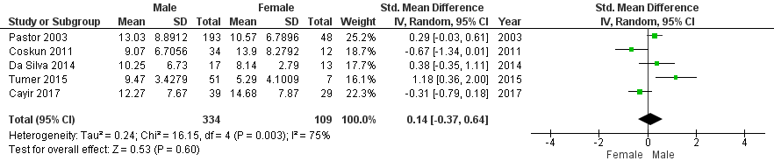

- Buccal cells micronucleus frequency between male and female in exposure group
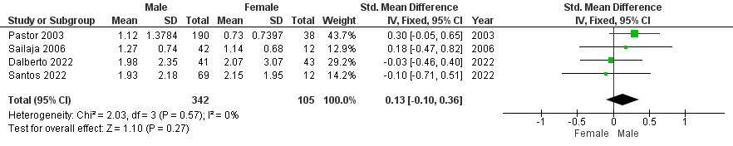
- Lymphocytes Binucleated cells between male and female in exposure group
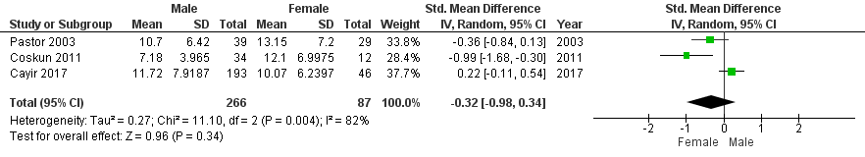

- Buccal cells binucleated cells between male and female in exposure group
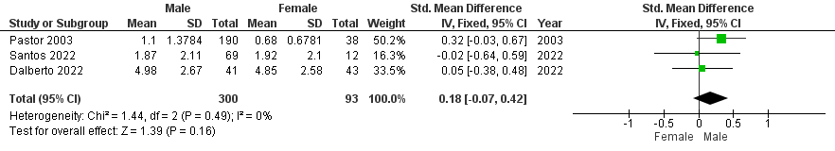

- CBPI between gender in exposure group
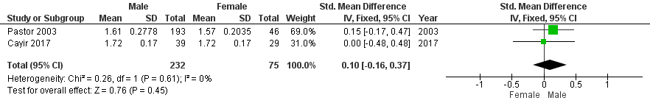

Supplementary Figure 3. Sub-analysis based on smoking status in pesticide exposed group. (A) micronucleus in lymphocytes; (B) micronucleus in buccal cells; (C) binucleated cells in Lymphocytes; (D) binucleated cells in buccal cells; (E) CBPI.
- Lymphocytes micronucleus frequency between smoking status in exposure group
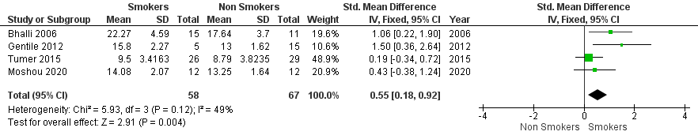

- Buccal Cells micronucleus frequency between smoking status in exposure group
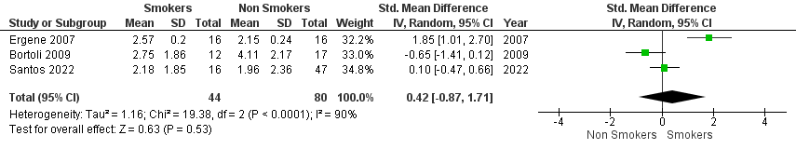
- Lymphocytes binucleated cells between smoking status in exposure group
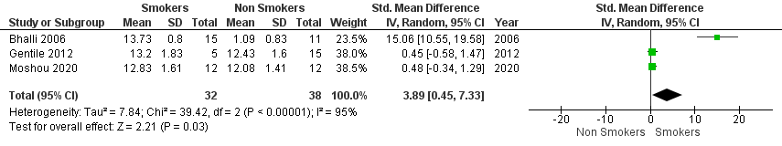
- CBPI between smoking status in exposed group
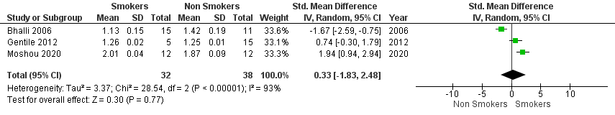

Supplementary Figure 4. Funnel plot and Egger’s test publication bias analysis. (A) micronucleus in lymphocytes; (B) micronucleus in buccal cells; (C) binucleated cells in buccal cells

- Micronucleus in lymphocytes
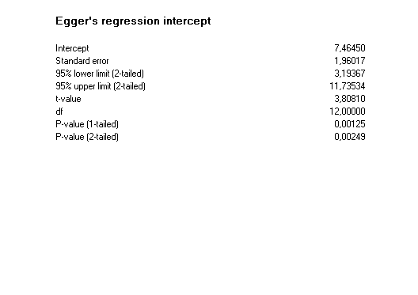
- Micronucleus in buccal cells
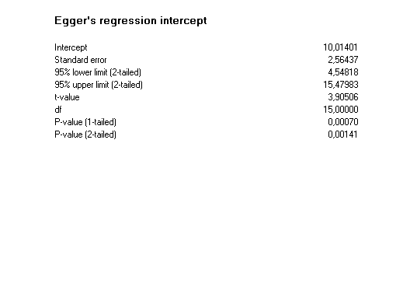
- Binucleated cells in buccal cells
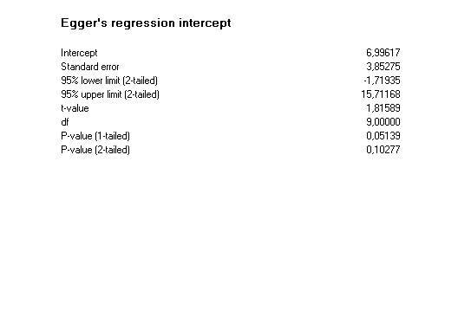
Supplementary Figure 5. Sensitivity test with leave one out analysis. (A) micronucleus in lymphocytes; (B) micronucleus in buccal cells; (C) binucleated cells in Lymphocytes; (D) binucleated cells in buccal cells; (E) CBPI.
- Micronuclei in Lymphocytes Sensitivity Test
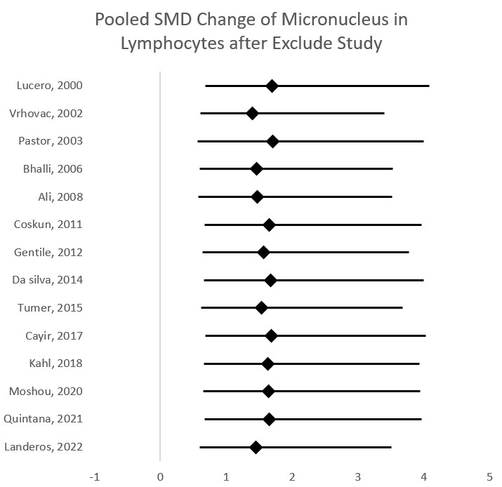
- Micronuclei in Buccal Cells Sensitivity Test
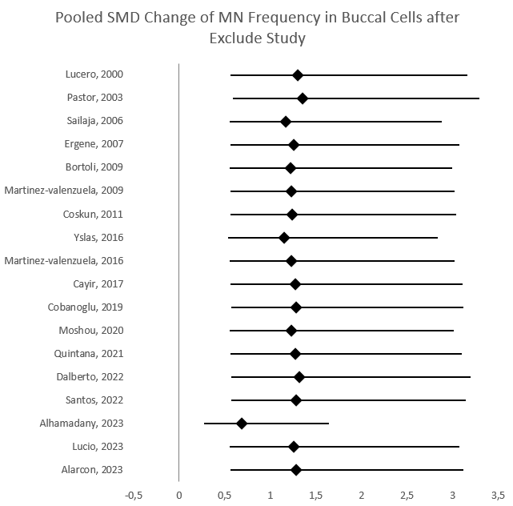

- Binucleated Cells in Lymphocytes Sensitivity Test
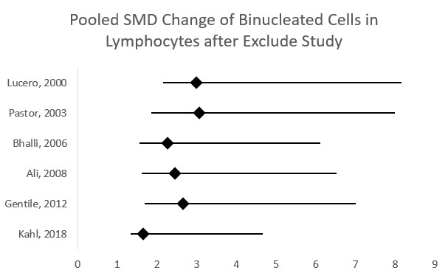
- Binucleated Cells in Buccal Cells Sensitivity Test
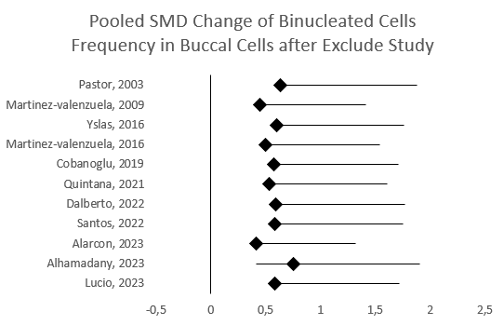
- CBPI Sensitivity Test
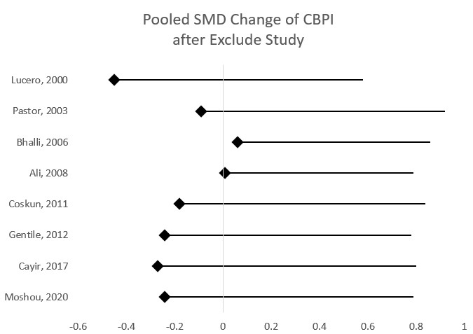

PRISMA Checklist
Section and Topic | Item # | Checklist item | Location where item is reported
TITLE
Title | 1 | Identify the report as a systematic review. | Title
ABSTRACT
Abstract | 2 | See the PRISMA 2020 for Abstracts checklist. | Abstract
INTRODUCTION
Rationale | 3 | Describe the rationale for the review in the context of existing knowledge. | Introduction
Objectives | 4 | Provide an explicit statement of the objective(s) or question(s) the review addresses. | Introduction, last paragraph
METHODS
Eligibility criteria | 5 | Specify the inclusion and exclusion criteria for the review and how studies were grouped for the syntheses. | Method (study protocol and study design, eligibility criteria)
Information sources | 6 | Specify all databases, registers, websites, organisations, reference lists and other sources searched or consulted to identify studies. Specify the date when each source was last searched or consulted. | Method (study protocol and study design, database searching and study selection)
Search strategy | 7 | Present the full search strategies for all databases, registers and websites, including any filters and limits used. | Method (database searching and study selection)
Selection process | 8 | Specify the methods used to decide whether a study met the inclusion criteria of the review, including how many reviewers screened each record and each report retrieved, whether they worked independently, and if applicable, details of automation tools used in the process. | Method (database searching and study selection)
Data collection process | 9 | Specify the methods used to collect data from reports, including how many reviewers collected data from each report, whether they worked independently, any processes for obtaining or confirming data from study investigators, and if applicable, details of automation tools used in the process. | Method (data extraction)
Data items | 10a | List and define all outcomes for which data were sought. Specify whether all results that were compatible with each outcome domain in each study were sought (e.g. for all measures, time points, analyses), and if not, the methods used to decide which results to collect. | Method (data extraction)
Data items | 10b | List and define all other variables for which data were sought (e.g. participant and intervention characteristics, funding sources). Describe any assumptions made about any missing or unclear information. | Method (data extraction)
Study risk of bias assessment | 11 | Specify the methods used to assess risk of bias in the included studies, including details of the tool(s) used, how many reviewers assessed each study and whether they worked independently, and if applicable, details of automation tools used in the process. | Method (risk of bias assessment)
Effect measures | 12 | Specify for each outcome the effect measure(s) (e.g. risk ratio, mean difference) used in the synthesis or presentation of results. | Method (statistical analysis)
Synthesis methods | 13a | Describe the processes used to decide which studies were eligible for each synthesis (e.g. tabulating the study intervention characteristics and comparing against the planned groups for each synthesis (item #5)). | Method (eligibility criteria)
Synthesis methods | 13b | Describe any methods required to prepare the data for presentation or synthesis, such as handling of missing summary statistics, or data conversions. | Method (statistical analysis)
Synthesis methods | 13c | Describe any methods used to tabulate or visually display results of individual studies and syntheses. | Method (statistical analysis)
Synthesis methods | 13d | Describe any methods used to synthesize results and provide a rationale for the choice(s). If meta-analysis was performed, describe the model(s), method(s) to identify the presence and extent of statistical heterogeneity, and software package(s) used. | Method (statistical analysis)
Synthesis methods | 13e | Describe any methods used to explore possible causes of heterogeneity among study results (e.g. subgroup analysis, meta-regression). | Method (statistical analysis)
Synthesis methods | 13f | Describe any sensitivity analyses conducted to assess robustness of the synthesized results. | Method (statistical analysis)
Reporting bias assessment | 14 | Describe any methods used to assess risk of bias due to missing results in a synthesis (arising from reporting biases). | Method (risk of bias assessment)
Certainty assessment | 15 | Describe any methods used to assess certainty (or confidence) in the body of evidence for an outcome. | -
RESULTS
Study selection | 16a | Describe the results of the search and selection process, from the number of records identified in the search to the number of studies included in the review, ideally using a flow diagram. | Results ( characteristic of included study)
Study selection | 16b | Cite studies that might appear to meet the inclusion criteria, but which were excluded, and explain why they were excluded. | Results (characteristic of included study)
Study characteristics | 17 | Cite each included study and present its characteristics. | Results (table 1)
Risk of bias in studies | 18 | Present assessments of risk of bias for each included study. | Supplementary files
Results of individual studies | 19 | For all outcomes, present, for each study: (a) summary statistics for each group (where appropriate) and (b) an effect estimate and its precision (e.g. confidence/credible interval), ideally using structured tables or plots. | Results (Meta-analysis of Micronucleus, Binucleated Cells, and CBPI) and supplementary files
Results of syntheses | 20a | For each synthesis, briefly summarise the characteristics and risk of bias among contributing studies. | Results (risk of bias assessment) and supplementary files
Results of syntheses | 20b | Present results of all statistical syntheses conducted. If meta-analysis was done, present for each the summary estimate and its precision (e.g. confidence/credible interval) and measures of statistical heterogeneity. If comparing groups, describe the direction of the effect. | Results (Meta-analysis of Micronucleus, Binucleated Cells, and CBPI) and supplementary files
Results of syntheses | 20c | Present results of all investigations of possible causes of heterogeneity among study results. | Results (Meta-analysis of Micronucleus, Binucleated Cells, and CBPI) and supplementary files
Results of syntheses | 20d | Present results of all sensitivity analyses conducted to assess the robustness of the synthesized results. | Results (last paragraph) and supplementary files
Reporting biases | 21 | Present assessments of risk of bias due to missing results (arising from reporting biases) for each synthesis assessed. | Results (risk of bias analysis) and supplementary files
Certainty of evidence | 22 | Present assessments of certainty (or confidence) in the body of evidence for each outcome assessed. | Results (Meta-analysis of Micronucleus, Binucleated Cells, and CBPI)
DISCUSSION
Discussion | 23a | Provide a general interpretation of the results in the context of other evidence. | Discussion (first paragraph)
Discussion | 23b | Discuss any limitations of the evidence included in the review. | Discussion (last paragraph)
Discussion | 23c | Discuss any limitations of the review processes used. | Discussion (last paragraph)
Discussion | 23d | Discuss implications of the results for practice, policy, and future research. | Discussion (last paragraph)
OTHER INFORMATION
Registration and protocol | 24a | Provide registration information for the review, including register name and registration number, or state that the review was not registered. | Abstract, method, supplementary files
Registration and protocol | 24b | Indicate where the review protocol can be accessed, or state that a protocol was not prepared. | Method
Registration and protocol | 24c | Describe and explain any amendments to information provided at registration or in the protocol. | Supplementary files
Support | 25 | Describe sources of financial or non-financial support for the review, and the role of the funders or sponsors in the review. | funding
Competing interests | 26 | Declare any competing interests of review authors. | Competing interest
Availability of data, code and other materials | 27 | Report which of the following are publicly available and where they can be found: template data collection forms; data extracted from included studies; data used for all analyses; analytic code; any other materials used in the review. | Data availability

From: Page MJ, McKenzie JE, Bossuyt PM, Boutron I, Hoffmann TC, Mulrow CD, et al. The PRISMA 2020 statement: an updated guideline for reporting systematic reviews. BMJ 2021;372:n71. doi: 10.1136/bmj.n71. This work is licensed under CC BY 4.0. To view a copy of this license, visit https://creativecommons.org/licenses/by/4.0/

