Supplementary Materials
Predictive models for screening of postoperative cognitive dysfunction in older surgical patients
Appendix 1. Instruments for risk assessment and interpretation of outcomes
Appendix 2. Flow of enrollment
Appendix 3. Predisposing factors for predicting POCD
Appendix 4. Predictive model of POCD at the preoperative stage
Appendix 5. Internal validation of independent indicators of POCD at the preoperative stage and corresponding clinical scores
Appendix 6. Internal validation of clinical scores and associated probabilities of a POCD positive result at the preoperative stage
Appendix 7. Calibration curve for the preoperative POCD predictive model
Appendix 8. Perioperative factors associated with POCD
Appendix 9. Predictive model of POCD at the immediate postoperative stage
Appendix 10. Internal validation of independent indicators of POCD at the immediate postoperative stage and corresponding clinical scores
Appendix 11. Internal validation of clinical scores and associated probabilities of a POCD positive result at the immediate postoperative stage
Appendix 12. Calibration curve for the immediate postoperative POCD predictive model

Appendix 1. Instruments for risk assessment and interpretation of outcomes
 | Instruments | Time at assessment |  |  |  |  |  | Interpretations [REF]
 | Instruments | Before surgery | After surgery |  |  |  |  | Interpretations [REF]
 | Instruments | 1 day | D1 | D2 | D3 | D5-9 | 3 M
Risk assessment
Comorbidities | Charlson Comorbidity Index |  |  |  |  |  |  | - A score of zero means that there are no comorbidities; the higher score predicted mortality rate [1]
Cognitive function | Modified Informant Questionnaire on Cognitive Decline in the Elderly (Modified IQCODE) |  |  |  |  |  |  | - Screening for dementia ≥ 3.42 scores [2]
Cognitive function | Montreal Cognitive Assessment (MoCA) |  |  |  |  |  |  | - Normal ≥ 25 scores  - Mild cognitive impairment 18-24 scores  - Dementia ≤ 17 scores [3, 4]
Delirium | Confusion Assessment Method (CAM algorithm) |  |  |  |  |  |  | For a diagnosis of delirium by CAM, the patient must display:  1. Presence of acute onset and fluctuating discourse  AND  2. Inattention  AND EITHER  3. Disorganized thinking  OR  4. Altered level of consciousness [5]
Delirium | Confusion Assessment Method for the Intensive Care Unit (CAM-ICU) |  |  |  |  |  |  | For a diagnosis of delirium by CAM-ICU, the patient must display the following:  1. Acute onset or fluctuating course  AND  2. Inattention  AND EITHER  3. Altered level of consciousness  OR  4. Disorganized thinking [6]
 | The Two-question Depression Screen (2Q) Scale |  |  |  |  |  |  | - If the patient's response to both questions is "no," the screen is negative.  - If the patient responded "yes" to either question, consider asking more detailed questions or using 9Q depression [7]
Psychological problems | The Nine-Question Depression-Rating (9Q) Scale |  |  |  |  |  |  | - No depression 0–6 scores  - Mild depression 7–12 scores  - Moderate depression 13–18 scores  - Major depression ≥ 19 scores [7]
Psychological problems | The Eight-Question Suicidal Risk (8Q) Scale | When 9Q ≥ 7 scores |  |  |  |  | When 9Q ≥ 7 scores | - No suicidality 0 scores  - Mild suicidality 1-8 scores  - Moderate suicidality 9-16 scores  - high suicidality ≥ 17 [7]
Functional status | The Barthel Index for Activities of Daily Living (Barthel ADL Index |  |  |  |  |  |  | - 0-20 Very severity disabled  - 25-45 Severity disabled  - 50-70 Moderately disabled  - 75-90 Mildly disabled  - 100 Physically independent but not necessarily normal or socially independent [8]
Functional status | The Lawton–Brody Instrumental Activities of Daily Living (IADL) |  |  |  |  |  |  | - A summary score ranges from 0 (low function, dependent) to 8 (high function, independent) for women  and 0 through 5 for men to avoid potential gender bias [9]
Frailty | The Thai version of the simple frailty questionnaire(T-FRAIL) |  |  |  |  |  |  | - Normal 0 score  - Pre-frail 1-2 scores  - Frail 3-5 scores [10]
Quality of life | European Quality of Life 5 Dimensions 5 Level Version (EQ-5D-5L) |  |  |  |  |  |  | - Death 0 score  - The best health 1 score [11]
Quality of life | Visual Analogue Scale (VAS) score |  |  |  |  |  |  | - The worst health you can imagine 0 score  - The best health you can imagine 100 scores [11]

Appendix 2. Flow of enrollment

Provided written informed consent
(n = 600)
Excluded during preoperative period (n = 16)
- Cancelled operation (n = 11)
- Withdrawal (n = 5)

(n = 584)
Excluded during postoperative period
Day 5-9 (n = 119)
- Death (n = 15)
- Withdrawal (n = 99)
- Inability to complete the assessment
(n = 5)

(n = 465)
The number of older patients arriving for surgery with anesthesia from December 2017 to December 2022 (n = 13683)
Excluded (n=13083)
- Ineligible criteria (n = 12541)
- Decline consent (n = 542)

Appendix 3. Predisposing factors for predicting POCD
 | Crude OR (95% CI) | p | Backward stepwise (likelihood ratio)  Adjusted OR (95% CI) | p
Variables
Age (years) | 0.97 (0.93-1.00) | 0.072 | .. | ..
Education level; lower than high school | 1.54 (1.01-2.35) | 0.045 | 1.54 (0.98-2.44) | 0.061
CKD stage 3b, 4, and 5 | 1.80 (1.04-3.12) | 0.036 | .. | ..
Ischemic heart disease/myocardial infarction | 2.61 (1.69-4.02) | <0.001 | 2.57 (1.63-4.06) | <0.001*
Atrial fibrillation | 1.92 (1.05-3.50) | 0.032 | .. | ..
Valvular heart disease | 1.82 (1.13-2.92) | 0.013 | .. | ..
Congestive heart failure | 1.97 (1.09-3.56) | 0.023 | .. | ..
Warfarin | 2.31 (1.19-4.48) | 0.013 | 2.53 (1.27-5.07) | 0.008*
Polypharmacy (current medication ≥ 5) | 1.82 (1.10-3.01) | 0.020 | .. | ..
VAS score | 0.98 (0.97-1.00) | 0.048 | .. | ..
IADL score | 0.88 (0.79-0.98) | 0.019 | .. | ..
Frailty; score 3–5 | 1.91 (1.07-3.39) | 0.026 | 1.87 (1.01-3.43) | 0.044*
Antiarrhythmic drug | 2.02 (1.31-3.10) | 0.001 | .. | ..
Antihypertensive drug | 2.11 (1.12-3.97) | 0.020 | .. | ..
Diuretics | 1.77 (1.12-2.82) | 0.014 | .. | ..

Abbreviations: CI: confidence interval; CKD: chronic kidney disease; IADL: instrumental activities of daily living; OR: odds ratio; POCD: postoperative cognitive dysfunction; VAS: visual analogue scale.
Appendix 4. Predictive model of POCD at the preoperative stage

 | Adjusted OR (95% CI) | Regression coefficient | Clinical score
Variables
Education level; lower than high school | 1.54 (0.98-2.44) | 0.436 | 1
Ischemic heart disease/myocardial infarction | 2.57 (1.63-4.06) | 0.946 | 2
Warfarin | 2.53 (1.27-5.07) | 0.932 | 2
Frailty; score 3–5 | 1.91 (1.07-3.39) | 0.625 | 1.5
Total score |  |  | 6.5

Abbreviations: CI: confidence interval; OR: odds ratio; POCD: postoperative cognitive dysfunction; ROC: receiver Operating Characteristic.
Predictive model of POCD at preoperative period = (1 * Education level lower than high school) + (2 * ischemic heart disease) + (2 * Warfarin) + (1.5 * Frail; score 3–5)
The area under ROC curve (95% CI) = 0.66 (0.60–0.72).

Appendix 5. Internal validation of independent indicators of POCD at the preoperative stage and corresponding clinical scores

 | Adjusted OR (95% CI) | Coefficient adjusted bootstrap internal validation | Clinical score
Variables
Education level; Lower than high school | 1.54 (0.98-2.44) | 0.383 | 1
Ischemic heart disease/Myocardial infarction | 2.57 (1.63-4.06) | 0.869 | 2
Warfarin | 2.53 (1.27-5.07) | 0.794 | 2
Frail; score 3-5 | 1.91 (1.07-3.39) | 0.482 | 1
Total score |  |  | 6
Predictive model of POCD at preoperative = (1 * education level lower than high school) + (2 * ischemic heart disease) + (2 * warfarin) + (1 * frailty score of 3-5)
Area under ROC curve (95% CI) = 0.67 (0.61-0.73)
Abbreviations: CI: confidence interval; OR: odds ratio; POCD: Postoperative cognitive dysfunction; ROC: receiver Operating Characteristic.

Appendix 6. Internal validation of clinical scores and associated probabilities of a POCD positive result at the preoperative stage

 | Probabilities | Sensitivity  (95% CI) | Specificity  (95% CI) | PPV  (95% CI) | NPV  (95% CI) | Accuracy  (95% CI) | Youden's index
Clinical scores
≥ 1 | 18.87 | 85.22  (77.39-91.15) | 31.40  (26.52-36.59) | 29.34  (27.22-31.55) | 86.40  (79.95-91.01) | 44.88  (40.27-49.56) | 0.17
≥ 2 | 26.83 | 67.83  (51.85-62.56) | 57.27  (51.85-62.56) | 34.67  (30.80-38.74) | 84.19  (80.09-87.58) | 59.91 (55.27-64.43) | 0.25
≥ 3 | 36.63 | 46.09  (36.75-55.63) | 78.20  (73.46-82.45) | 41.41  (34.79-48.35) | 81.27  (78.41-83.83) | 70.15  (65.74-74.31) | 0.24
≥ 4 | 47.68 | 18.26  (11.67-26.55) | 94.48  (91.51-96.64) | 52.50  (38.14-66.46) | 77.57  (75.96-79.09) | 75.38  (71.18-79.26) | 0.13
≥ 5 | 58.96 | 4.35  (1.43-9.85) | 98.84  (97.05-99.68) | 55.56  (25.45-82.07) | 75.56  (74.80-76.30) | 75.16  (7.95-79.05) | 0.04
Abbreviations: CI: confidence interval; PPV: positive predictive value; NPV: negative predictive value.

Appendix 7. Calibration curve for the preoperative POCD predictive model

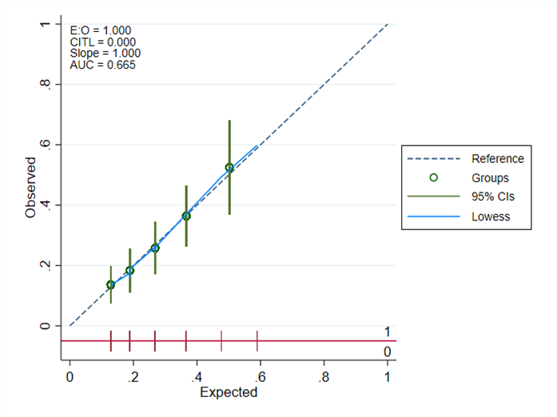
Abbreviations: AUC: area under the curve; CIs: confidence intervals; CITL: calibration-in-the-large; E:O: expected/observed ratio.

Appendix 8. Perioperative factors associated with POCD

 | Crude OR (95% CI) | p | Backward Stepwise (Likelihood Ratio)  Adjusted OR (95% CI) | p
Variables
Age (years) | 0.97 (0.93-1.00) | 0.072 | .. | ..
Education level; lower than high school | 1.54 (1.01-2.35) | 0.045 | .. | ..
CKD stage 3b, 4, and 5 | 1.80 (1.04-3.12) | 0.036 | .. | ..
Ischemic heart disease/myocardial infarction | 2.61 (1.69-4.02) | <0.001 | .. | ..
Atrial fibrillation | 1.92 (1.05-3.50) | 0.032 | .. | ..
Valvular heart disease | 1.82 (1.13-2.92) | 0.013 | .. | ..
Congestive heart failure | 1.97 (1.09-3.56) | 0.023 | .. | ..
Warfarin | 2.31 (1.19-4.48) | 0.013 | .. | ..
Polypharmacy (current medication ≥ 5) | 1.82 (1.10-3.01) | 0.020 | .. | ..
VAS score | 0.98 (0.97-1.00) | 0.048 | .. | ..
IADL score | 0.88 (0.79-0.98) | 0.019 | 0.87 (0.77-0.98) | 0.020*
Frailty; score 3-5 | 1.91 (1.07-3.39) | 0.026 | .. | ..
Antiarrhythmic drug | 2.02 (1.31-3.10) | 0.001 | .. | ..
Antihypertensive drug | 2.11 (1.12-3.97) | 0.020 | .. | ..
Diuretics | 1.77 (1.12-2.82) | 0.014 | .. | ..
Cardiac surgery | 2.57 (1.63-4.03) | <0.001 | .. | ..
ASA classification; ASA > 2
Midazolam | 2.22 (1.44-3.42) | <0.001 | .. | ..
Isoflurane | 2.77 (1.68-4.55) | <0.001 | 2.23 (1.28-3.90) | 0.005*
Fentanyl | 3.30 (0.76-14.39) | 0.110 | .. | ..
Vasopressor use | 2.62 (1.40-4.90) | 0.003 | .. | ..
Blood product | 3.38 (2.08-5.49) | <0.001 | 2.73 (1.58-4.71) | <0.001*

Abbreviations: ASA: American Society of Anesthesiologists physical status; CI: confidence interval; CKD: chronic kidney disease; IADL: instrumental activities of daily living; OR: odds ratio; POCD: postoperative cognitive dysfunction; VAS: visual analogue scale.
Appendix 9. Predictive model of POCD at the immediate postoperative stage

 | Adjusted OR (95% CI) | Regression coefficient | Clinical score
Variables
IADL (score 0–8) | 0.87 (0.77-0.98) | -0.137 | -1
Isoflurane | 2.23 (1.28-3.90) | 0.806 | 6
Blood product | 2.73 (1.58-4.71) | 1.006 | 7
Total score (min -8, max 13)

Abbreviations: CI: confidence interval; IADL: Instrumental Activities of Daily Living; OR: odds ratio; POCD: postoperative cognitive dysfunction; ROC: receiver Operating Characteristic.
Predictive model of POCD = (-1* IADL Score) + (6 * Isoflurane) + (7* any type of intraoperative blood transfusion)
The area under ROC curve (95% CI) = 0.68 (0.62-0.74)

Appendix 10. Internal validation of independent indicators of POCD at the immediate postoperative stage and corresponding clinical scores

 | Adjusted odds ratio (95% CI) | Coefficient adjusted bootstrap internal validation | Clinical score
Variables
IADL (score 0-8) | 0.87 (0.77-0.98) | -0.118 | -1
Isoflurane | 2.23 (1.28-3.90) | 0.617 | 5
Blood product | 2.73 (1.58-4.71) | 0.941 | 8
Total score (min -8, max 13)
Predictive model of POCD = (-1* IADL Score) + (5 * isoflurane) + (8* any type of intraoperative blood transfusion)
Area under ROC curve (95% CI) = 0.68 (0.63-0.74)
Abbreviations: CI: confidence interval; OR: odds ratio; POCD: Postoperative cognitive dysfunction; ROC: receiver Operating Characteristic.

Appendix 11. Internal validation of clinical scores and associated probabilities of a POCD positive result at the immediate postoperative stage

 | Probabilities | Sensitivity  (95% CI) | Specificity  (95% CI) | PPV  (95% CI) | NPV  (95% CI) | Accuracy  (95% CI) | Youden's index
Clinical scores
≥ -2 | 20.40 | 78.95  (70.31-86.02) | 46.47  (41.07-51.93) | 33.09  (30.13-36.19) | 86.81  (81.92-90.53) | 54.63  (49.92-59.27) | 0.25
≥ -1 | 22.49 | 78.07  (69.35-85.28) | 48.24  (42.81-53.69) | 33.58  (30.51-36.81) | 86.77  (82.02-90.42) | 55.73  (51.02-60.36) | 0.26
≥ 0 | 24.74 | 77.19  (68.40-84.53) | 49.12  (43.68-54.57) | 33.72  (30.57-37.02) | 86.53  (81.84-90.15) | 56.17  (51.47-60.79) | 0.26
≥ 1 | 27.13 | 65.79  (56.32-74.42) | 62.06  (56.67-67.24) | 36.76  (32.47-41.28) | 84.40  (80.54-87.61) | 63.00  (58.37-67.45) | 0.28
≥ 2 | 29.65 | 52.63  (43.06-62.06) | 70.00  (64.82-74.83) | 37.04  (31.68-42.74) | 81.51  (78.21-84.41) | 65.64  (61.07-70.00) | 0.23
≥ 3 | 32.31 | 49.12  (39.64-58.65) | 75.8  (70.97-80.33) | 40.58  (34.37-47.10) | 81.65  (78.62-84.32) | 69.16  (64.69-73.38) | 0.25
≥ 4 | 35.09 | 42.98  (33.75-52.59) | 81.18  (76.61-85.19) | 43.36  (36.06-50.96) | 80.94  (78.22-83.39) | 71.59  (67.20-75.69) | 0.24
Abbreviations: CI: confidence interval; PPV: positive predictive value; NPV: negative predictive value.

Appendix 12. Calibration curve for the immediate postoperative POCD predictive model

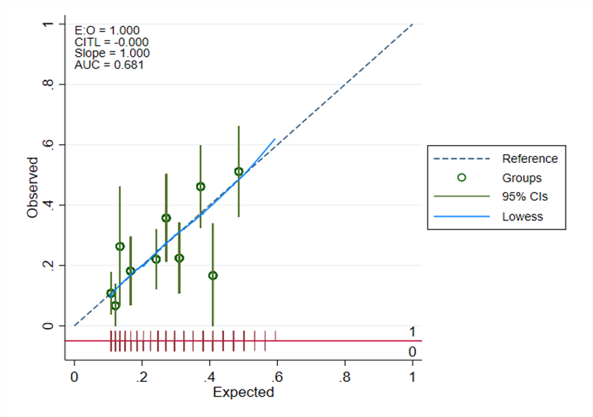
Abbreviations: AUC: area under the curve; CIs: confidence intervals; CITL: calibration-in-the-large; E:O: expected/observed ratio.

REFERENCES
1. Charlson ME, Pompei P, Ales KL, MacKenzie CR. A new method of classifying prognostic comorbidity in longitudinal studies: development and validation. J Chronic Dis. 1987;40(5):373-83.
2. Siri S, Okanurak K, Chansirikanjana S, Kitayaporn D, Jorm AF. Modified Informant Questionnaire on Cognitive Decline in the Elderly (IQCODE) as a screening test for dementia for Thai elderly. Southeast Asian J Trop Med Public Health. 2006;37(3):587-94.
3. Nasreddine ZS, Phillips NA, Bédirian V, Charbonneau S, Whitehead V, Collin I, et al. The Montreal Cognitive Assessment, MoCA: a brief screening tool for mild cognitive impairment. J Am Geriatr Soc. 2005;53(4):695-9.
4. Hoops S, Nazem S, Siderowf AD, Duda JE, Xie SX, Stern MB, Weintraub D. Validity of the MoCA and MMSE in the detection of MCI and dementia in Parkinson disease. Neurology. 2009;73(21):1738-45.
5. Wongpakaran N, Wongpakaran T, Bookamana P, Pinyopornpanish M, Maneeton B, Lerttrakarnnon P, et al. Diagnosing delirium in elderly Thai patients: utilization of the CAM algorithm. BMC Fam Pract. 2011;12:65.
6. Pipanmekaporn T, Wongpakaran N, Mueankwan S, Dendumrongkul P, Chittawatanarat K, Khongpheng N, Duangsoy N. Validity and reliability of the Thai version of the Confusion Assessment Method for the Intensive Care Unit (CAM-ICU). Clin Interv Aging. 2014;9:879-85.
7. Kongsuk T, Supanya S, Kenbubpha K, Phimtra S, Sukhawaha S, Leejongpermpoon J. Services for depression and suicide in Thailand. WHO South-East Asia Journal of Public Health. 2017;6:34-8.
8. Mahoney FI, Barthel DW. FUNCTIONAL EVALUATION: THE BARTHEL INDEX. Md State Med J. 1965;14:61-5.
9. Lawton MP, Brody EM. Assessment of older people: self-maintaining and instrumental activities of daily living. Gerontologist. 1969;9(3):179-86.
10. W TS, Mahavisessin W, Srinonprasert V, Siriussawakul A, Aekplakorn W, Limpawattana P, et al. Validity and reliability of the Thai version of the simple frailty questionnaire (T-FRAIL) with modifications to improve its diagnostic properties in the preoperative setting. BMC Geriatr. 2022;22(1):161.
11. Pattanaphesaj J, Thavorncharoensap M, Ramos-Goñi JM, Tongsiri S, Ingsrisawang L, Teerawattananon Y. The EQ-5D-5L Valuation study in Thailand. Expert Rev Pharmacoecon Outcomes Res. 2018;18(5):551-8.

